ERTMS/ETCS – Class 1
System Requirements Specification
Chapter 3
Principles
REF : | SUBSET-026-3
ISSUE : | 2.3.0
DATE : | 24/02/2006

Company | Technical Approval | Management approval
ALCATEL

ALSTOM

ANSALDO SIGNAL

BOMBARDIER

INVENSYS RAIL

SIEMENS

Modification History
Issue Number  Date | Section Number | Modification / Description | Author/Editor
1.0.1  990307 | All | Merge of Basic + Detailed Principles  Removing redundant material, correcting text and adding proposals. | HE
1.1.0  990423 | All | Class P Official Issue | HE
1.1.1  990521 | All | Corrections after UNISIG review. | KL
1.1.2  990713 | All | Additional functions for class 1 and changes related to these functions in other parts | KL
1.1.3  990722 | All | Changes according to review of version 1.1.2 | KL
1.1.4  990729 | All | Editorial corrections, finalisation meeting Stuttgart 990729 | HE
1.2.0  990730 | Version number | Release version | HE
1.3.0  991201 | All | Corrections and new functions according to ECSAG and UNISIG comments | KL
1.3.1  991217 | All | Corrections after UNISIG review 15 December 99 | KL
2.0.0  991222 | Minor editing | Release Version | Ch. Frerichs (ed.)
2.0.1  000921 | All | Corrections after UNISIG review 15 June 00 | KL
2.1.0  001017 | Most | Corrections after UNISIG review 11 October 00 | KL
2.2.0  010108 | Section 3.18.4.6.6 – 3.18.4.6.8 removed | Changes as decided on Steering Committee meeting 13 December 2000 (changes from 2.0.0 marked) | KL
2.2.2  020201 | Refer to document: SUBSET–026 Corrected Paragraphs, Issue 2.2.2 |  | KL
2.2.4 SG checked  040528 | Including all CLRs agreed with the EEIG (see “List of CLRs agreed with EEIG for SRS v2.2.4” dated 28/05/04)  Affected clauses see change marks |  | H. Kast
2.2.5  210105 | Incorporation of solution proposal for CLR 007 with EEIG users group comments  Corrections according to erratum list agreed in SG meeting 170105 |  | AH
2.2.6  050301 | Including all CLRs being in state “EEIG pending” as per list of CLRs extracted on 28/01/05. |  | OG
2.2.7  220705 | Including all CLRs extracted from "CR-Report_10.6.05-by number.rtf" and mentioned in column 2.2.7 in "CR status 13.6.05.xls"  22/07/05 Changes for CR 126 included (HK) |  | OG
2.2.8  211105 | Change marks cleaned up and updated according to last CRs decisions (including split of CRs7&126) |  | OG
2.2.9  24/02/06 | Including all CRs that are classified as "IN" as per SUBSET-108 version 1.0.0  Removal of all CRs that are not classified as "IN" as per SUBSET-108 version 1.0.0, with the exception of CRs 63,98,120,158,538 |  | OG
2.3.0  24/02/06 | Release version |  | HK

Table of Contents
3.1 Modification History 2
3.2 Table of Contents 4
3.3 Introduction 7
3.3.1 Scope and purpose 7
3.4 Balise configuration and linking 7
3.4.1 Balise Configurations – Balise Group Definition 7
3.4.2 Balise Co-ordinate System 7
3.4.3 Balise Information Types and Usage 10
3.4.4 Linking 11
3.5 Management of Radio Communication 13
3.5.2 General 13
3.5.3 Establishing a communication session 13
3.5.4 Maintaining a communication session 16
3.5.5 Terminating a communication session 17
3.5.6 Registering to the Radio Network 18
3.6 Location Principles and Train Position 19
3.6.1 General 19
3.6.2 Location of Data Transmitted to the On-Board Equipment 20
3.6.3 Validity direction of transmitted Information 22
3.6.4 Train Position Confidence Interval 27
3.6.5 Position Report (Level 2/3 only) 29
3.6.6 Geographical position reporting 32
3.7 Completeness of data for safe train movement 34
3.7.1 Completeness of data 34
3.7.2 Responsibility for completeness of information 35
3.7.3 Extension, replacement of track description and linking information 35
3.8 Movement authority 36
3.8.1 Characteristics of a MA 36
3.8.2 MA request to the RBC 38
3.8.3 Structure of a Movement Authority (MA) 39
3.8.4 Use of the MA on board the train 41
3.8.5 MA Update and Extension 43
3.8.6 Co-operative shortening of MA (Level 2 and 3 only) 47
3.9 Means to transmit In-fill information (Level 1 only) 48
3.9.1 General 48
3.9.2 In-fill by loop 48
3.9.3 In-fill by radio 49
3.10 Emergency Messages 51
3.10.1 General 51
3.10.2 Emergency Stop 52
3.10.3 Revocation of an Emergency Message 52
3.11 Static Speed Restrictions and Gradients 53
3.11.1 Introduction 53
3.11.2 Definition of Static Speed Restriction 53
3.11.3 Static Speed Profile (SSP) 54
3.11.4 Axle load Speed Profile 55
3.11.5 Temporary Speed Restrictions 56
3.11.6 Signalling related speed restrictions 56
3.11.7 Mode related speed restrictions 57
3.11.8 Train related speed restriction 57
3.11.9 Most Restrictive Speed Profile (MRSP) 57
3.11.10 Gradients 58
3.12 Other Profiles 59
3.12.1 Track Conditions 59
3.12.2 Route Suitability 60
3.12.3 Text Transmission 61
3.12.4 Mode profile 63
3.13 Dynamic Speed Monitoring 64
3.13.1 Introduction 64
3.13.2 General Requirements 64
3.13.3 Input for the speed monitoring 64
3.13.4 Supervision Limits 67
3.13.5 Special Requirements for the Ceiling Speed Monitoring Section (CS) 69
3.13.6 Special Requirements for the Target Speed Monitoring 69
3.13.7 Release Speed (RS) Monitoring 72
3.13.8 Train trip monitoring on passing the EOA/LOA 73
3.14 Brake Command Handling and Protection against Undesirable Train Movement 74
3.14.1 Brake Command Handling 74
3.14.2 Roll Away Protection 75
3.14.3 Reverse Movement Protection 75
3.14.4 Standstill supervision 75
3.15 Special functions 76
3.15.1 RBC/RBC Handover 76
3.15.2 Handling of Trains with Non Leading Engines 79
3.15.3 Splitting/joining 79
3.15.4 Reversing of movement direction 80
3.15.5 Track ahead free 80
3.15.6 On-board functionality for level STM 81
3.15.7 Tolerance of Big Metal Mass 81
3.16 Data Consistency 82
3.16.1 Criteria of consistency 82
3.16.2 Balises 82
3.16.3 Radio 86
3.17 System Configuration Management 89
3.17.1 Aim and objectives 89
3.17.2 Evolution of the versions 89
3.17.3 Management of ERTMS/ETCS system versions 90
3.18 System Data 91
3.18.1 Fixed Values 91
3.18.2 National / Default Values 91
3.18.3 Train Data 92
3.18.4 Additional Data 93
3.18.5 Date and Time 95
3.19 Data Entry / Modification Process 95
3.20 Recording of Juridical Data 95
3.20.1 On-board Recorder 95
Appendix to Chapter 3 97
A3.1 List of Fixed Value Data 97
A3.2 List of National / Default Data 97
A3.3 List of events to be recorded in the Juridical Recorder 98
A3.4 Handling of Stored Information in specific Situations 100

Introduction

Scope and purpose

The chapter 3, Principles, specifies the system principles of ETCS/ERTMS. These principles apply to on-board and trackside subsystems and are mainly derived from FRS.

The principles define the operational and technical behaviour of the system in general and functional terms.

The chapter is divided into subchapters. For each subchapter, when applicable, references are given to corresponding chapters in the FRS. In each subchapter normally several requirements are defined. Each requirement is identified with a unique identification number.

Notes, Justifications and Examples are only informative and shall not be regarded as requirements.

Balise configuration and linking

Balise Configurations – Balise Group Definition
FRS reference: - none

A balise group shall consist of between one and eight balises.

In every balise shall at least be stored:
- The internal number (from 1 to 8) of the balise
- The number of balises inside the group
- The balise group identity.

The internal number of the balise describes the relative position of the balise in the group.

Balise Co-ordinate System
FRS reference: - none

Every balise group has its own co-ordinate system.

Balise groups composed of two or more balises

The origin of the co-ordinate system for each balise group shall be given by the balise number 1 (called location reference) in the balise group.

The nominal direction of each balise group is defined by increasing internal balise numbers.
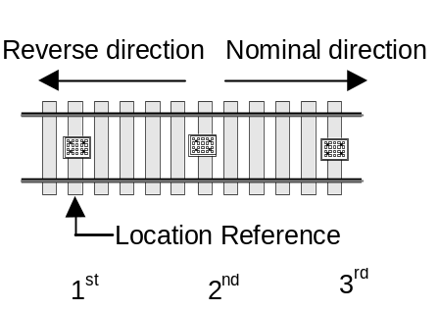
Figure 1: Orientation of the balise group

Balise groups composed of a single balise

Note: Balise groups consisting of only one single balise are referred to as "single balise groups" in the following.

Level 1:

The assignment of the co-ordinate system shall be by means of linking data.

For balise groups consisting of a single balise, the information "direction with which the linked balise group will be passed over" received from a previous balise group shall assign a co-ordinate system to the balise.

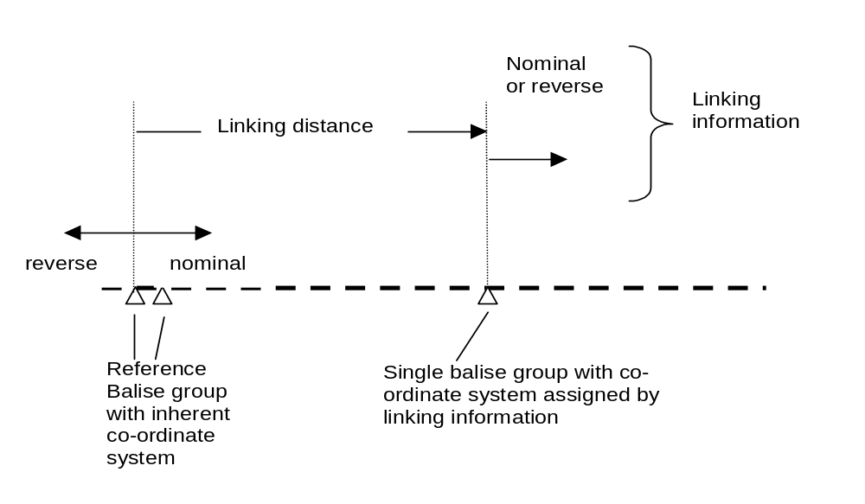
Figure 2: Assignment of a co-ordinate system to a single balise group by linking

The reference for the linking data shall be either a single balise group if a co-ordinate system has been assigned to it before, or a balise group consisting of two or more balises (with "inherent" co-ordinate system)

Level 2/3:

If the on-board equipment cannot evaluate the orientation of the single balise group, i.e. no linking information is available on-board, the RBC shall be requested to assign a co-ordinate system as follows (refer to section 3.6.5.1.3)
- If only one single balise group is known to the on-board equipment, the on-board shall report its position in a special position report using this single balise group as LRBG.
The special position report shall include the distance travelled since the single balise group was detected, but with all information related to the balise group orientation set to unknown.
- When yet another single balise group is detected: The on-board equipment shall report its position by means of
- New single balise group detected, identified as LRBG
and
- The previous one, serving as direction reference
- 1. The memorised balise groups (as described in c)2. and d) below) shall be deleted if the train changes orientation
- 2. If the on-board equipment is currently not able to contact the RBC when single balise groups are detected then
- The on-board equipment shall memorise the last two single balise groups detected
- When the on-board equipment establishes data communication with the RBC, it shall report its position based on memorised balise group(s).
- LRBGs reported to the RBC shall be memorised by the on-board equipment, together with their sequence and the internal train orientation when they were detected, until the RBC has assigned a co-ordinate system.
Justification: The RBC might assign a co-ordinate system to an older LRBG than the last one reported by the on-board equipment.
- When the RBC is able, from the sequence of the reported single balise groups, to identify in an unambiguous way the track related orientation of the train, it shall assign a co-ordinate system to the last single balise group received from the on-board equipment. I.e. the RBC informs the on-board equipment if the last single balise group was passed in nominal or reverse direction.
- The co-ordinate system assigned to the balise group shall be used by the on-board equipment only if the balise has been reported together with a second balise
- In reference to the train orientation with which the balise group was passed
and
- In reference to the current train orientation.
- Note: If the orientation is unknown, the special position report reporting two single balise groups provides all information the RBC needs to assign a co-ordinate system to the LRBG. The position report containing only one single balise group does not allow the RBC to do so unless with additional information, however this position report is useful in providing an early indication of the train position.

Once a co-ordinate system has been assigned by the RBC and sent to the on-board equipment, the RBC can assign a co-ordinate system of further single balise groups by means of linking.

Balise groups composed of one pair of duplicated balises

A group of two balises duplicating each other shall be treated as a single balise group in case where only one balise is correctly read.

Balise Information Types and Usage

Level 1

All information to the on-board system shall be given from balise groups or from in-fill devices (see section 3.9).

A balise may contain information for both nominal and reverse direction. This information can be of the following type (please refer to section 3.8.5):
- Normal
- Repositioning
- In-fill.

Note: Repositioning information is sent to correct previously given information.

Note: In-fill information is referring to the location reference of an announced balise group.

Some information shall be read also in sleeping mode and when no linking information is available (see Chapter 4 Use of received information). If such information is transmitted by balises, balise groups consisting of at least two balises shall be used.

Levels 2 and 3

Some information (see Chapter 4 Use of received information) shall be read also in sleeping mode and when no radio contact or linking information is available. If such information is transmitted by balises, balise groups consisting of at least two balises shall be used.

Balise groups shall be used for location information in levels 2 and 3.

Linking
FRS reference: - none

Introduction

Aim of linking:
- To determine whether a balise group has been missed or not found within the expectation window (see section 3.4.4.4) and take the appropriate action.
- To assign a co-ordinate system to balise groups consisting of a single balise.
- To correct the confidence interval due to odometer inaccuracy (see section 3.6.4).

A balise group is linked when its linking information (see section 3.4.4.2) is known in advance.

Note: In cases where a balise group contains repositioning information, the term linked also applies since the balise group is announced, marked as linked and contains repositioning information marked accordingly.

Content of linking information

Linking information shall be composed of:
- The identity of the linked balise group.
- Where the location reference of the group has to be found.
- The accuracy of this location.
Note: If the reference balise is duplicated, it is the trackside responsibility to define the location accuracy to cover at least the location of the two duplicated balises.
- The direction with which the linked balise group will be passed over (nominal or reverse).
- The reaction required if a data consistency problem occurs with the expected balise group.

Instead of the identity of a linked balise group it shall be possible to identify a following linked balise group as unknown but containing repositioning information

Note 1: The announced orientation of the balise group can be either nominal or reverse as appropriate, or unknown. If unknown, a balise group of at least two balises is required to send the repositioning information.

Note 2: Regarding the repositioning information, see chapter 3.8.5.3.5 and 3.8.5.2.

Note 3: In case the identity of the next balise group is not unambiguously known because the route is not known by the trackside, this feature allows to link this balise group.

For each linked balise group, the trackside shall select one of the following reactions to be used in case of data inconsistencies:
- Train trip (Trip mode, see Chapter 4)
- Command service brake
- No reaction
For further details see section 3.16.2.

Unlinked Balise Groups

A balise group, which contains information that must be considered even when the balise group is not announced by linking, is called an unlinked balise group.

Unlinked balise groups shall consist at minimum of two balises.

Unlinked balise groups shall always contain the unlinked balise group qualifier.

Rules related to linking

When no linking information is used on-board, all balise groups shall be taken into account.

When linking information is used on-board, only balise groups marked as linked and included in the linking information and balise groups marked as unlinked shall be taken into account.

The on-board equipment shall accept a balise group marked as linked and included in the linking information (i.e. the balise giving the location reference) from
- when the max safe front end of the train has passed the first possible location of the balise group
until
- the min safe front end of the train has passed the last possible location of the balise group
taking the offset between the front of the train and the balise antenna into account.

Note: The first possible location and the last possible location of the balise group are defined by the linking distance and the location accuracy.

Note: The interval between the outer limits to accept the balise group defines the expectation window.

In case of a balise group containing repositioning information, the first possible location shall start from the previously linked balise group.

Management of Radio Communication

Note: the following section refers to the behaviour of the user application interacting with Euroradio protocols. How the messages are actually transported from the sender to the receiver user application is not relevant for this description.

General

Each communication session managed by an entity shall allow the exchange of data with only one other entity.

Note: in the following sections reference is made to safe connections, whose definition and management is contained in Euroradio specification.

The information Initiation of a Communication Session and Version not Compatible (see sections 3.5.3 and 3.17) shall be the same in every system version.

Establishing a communication session

It shall be possible for ERTMS/ETCS on-board equipment and RBC to initiate a communication session.

A Radio In-fill Unit (see section 3.9.3) shall never initiate a communication session.

Note: Only communication sessions between an ERTMS/ETCS on-board equipment and a trackside equipment (RBC or Radio In-fill Unit) are considered here.

The on-board shall establish a communication session
- At Start of Mission (only if level 2 or 3).
- If ordered from trackside, unless currently being established or already established with the same RBC/ RIU.

The order to contact an RBC shall include
- The identity of the RBC.
- The telephone number to the RBC.
- The action to be performed (establish/terminate the session).
- Whether this applies also to Sleeping units.

See table at the end of section 3.5.3.

If the order to establish a communication session with an RBC is received and accepted by ERTMS/ETCS on-board equipment already in session with another RBC, the existing communication session shall be terminated (see 3.5.5.2 for details) and the new one shall be established. Exception : an RBC/RBC Handover is engaged and the order relates to the Accepting RBC.

The order to contact a Radio In-fill Unit shall include
- The identity of the Radio In-fill Unit
- The telephone number of the Radio In-fill Unit
- The action to be performed (establish/terminate the session).

If the establishment of a communication session is initiated by the on-board, it shall be performed according to the following steps:
- The on-board shall request the set-up of a safe connection with the trackside. This attempt shall be repeated until successful or a defined number of times (see Appendix A3.1) If unsuccessful, the driver shall be informed that no connection was established.
- As soon as the safe connection is set-up, the on-board shall send the message Initiation of communication session to the trackside.
- As soon as the trackside receives the information, it shall send the system version.

When the on-board receives the system version it shall consider the communication session established and:
- If compatible with the trackside, it shall send a session established report, including its telephone numbers, to the trackside.
- If not compatible, it shall inform the trackside.

When the trackside receives the session established report or the information that versions are not compatible, it shall consider the communication session established.

Note: the incompatibility of system version is an error condition that triggers on-board to request the terminating the communication session. See section 3.5.5.
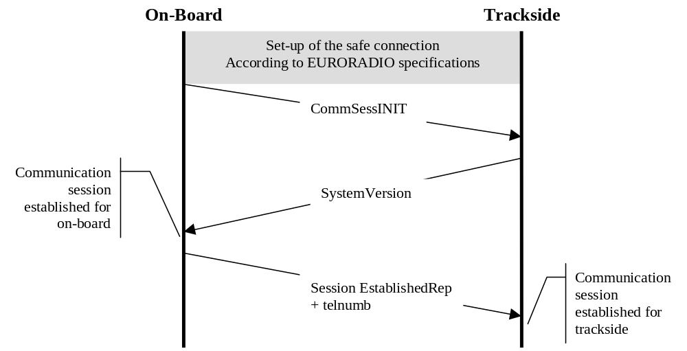

Figure 3: Establishment initiated by on-board

If the establishment of a communication session is initiated by the RBC, it shall be performed according to the following steps:
- The trackside shall request the set-up of a safe connection with the on-board.
- As soon as the safe connection is set-up, the trackside shall send the message Initiation of communication session to the on-board.
- When the on-board receives the information, it shall consider the communication session established and send a session established report to the trackside.
- When the trackside receives the session established report, it shall consider the communication session established.
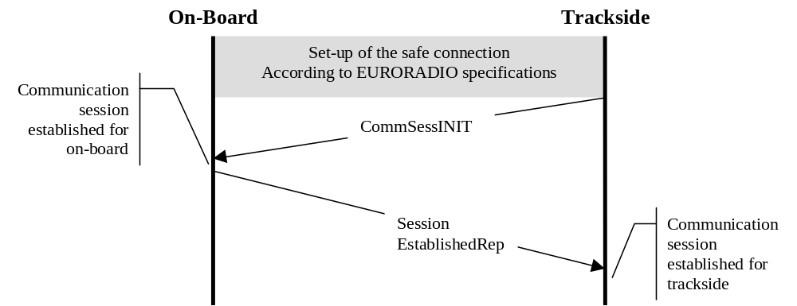

Figure 4: Establishment initiated by the RBC

In case the RBC is the initiator, the first message from RBC to on-board shall have the time-stamp set to "unknown"

Note: In the case the RBC is the initiator, there is no need to verify the compatibility of the system versions and for the on-board to send its telephone numbers, because the on-board is obviously already known to the RBC.

Intentionally deleted.

If a short number shall be used (considering trackside call routing), that number can be programmed into the balise instead of the normal phone number.

An order to contact the RBC may contain a special value for the RBC phone number indicating that the on-board shall use the on-board short number.

Note: The on-board stored short number for calling the RBC is defined by EIRENE.

Option | Balise data content | Train reaction
1 | Intentionally deleted | Intentionally deleted
2 | Order to contact RBC  RBC ID  Special value for RBC phone number: use on-board stored short number | Contact given RBC by using RBC ID and the on-board short number.  Note: If the short number does not direct to the RBC with the given RBC ID, the connection will be terminated (EURORADIO functionality).
3 | Order to contact RBC  RBC ID + RBC phone number | Contact given RBC by using RBC ID and the RBC phone number

Maintaining a communication session

When a communication session was established and in case of accidental loss of the safe connection and if the trackside has not ordered a disconnection, the involved entities shall consider the communication session still established.

Only the on-board equipment shall try to set-up a new safe connection.

The attempts shall be repeated , until
- The safe connection is set-up.
or
- Conditions for stopping the attempts are met (as defined in A3.1). The on-board shall in this case consider the session as terminated.

When the safe connection is lost inside an announced radio hole (see 3.12.1.3), the on-board equipment shall try to re-establish the radio connection at the end of the radio hole.

Terminating a communication session

The termination of a communication session shall be initiated only by the on-board and in the following cases:
- If an order is received from trackside (RBC or balise groups) (see section 3.5.3.5 concerning the content of the order).
- If an error condition requiring the termination of the communication session is detected on-board (e.g., not compatible system versions between on-board and trackside).
- The train is rejected by RBC during Start of Mission.

The on-board equipment shall terminate the communication session according to the following steps:
- The on-board equipment shall send a Termination of communication session message.
- As soon as this information is received, the trackside shall consider the communication session terminated and send an acknowledgement to the on-board.
- When the acknowledgement is received the on-board shall consider the communication session terminated and request the release of the safe connection with trackside.

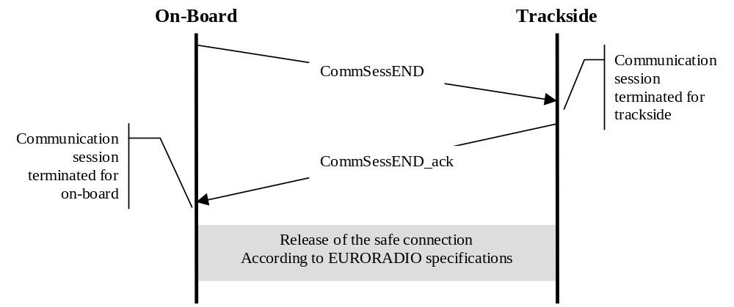
Figure 5: Termination of a communication session

No further message shall be sent by the on-board after the message End of communication session.

No further message shall be sent by the trackside after the message Acknowledgement of the end of communication session.

The information End of Communication Session and corresponding Acknowledgement shall be the same in every system version.

Messages from the RBC received onboard after the message “End of communication session” has been sent shall be ignored with the exception of the acknowledgement of the communication session termination.

Registering to the Radio Network

ERTMS/ETCS on-board equipment shall order the registration of its connected Mobile Terminal(s) to a Radio Network :
- At power-up
- At Start of Mission (only if level 2 or 3 following driver data entry)
- If ordered from the trackside

When powered-off, ERTMS/ETCS on-board equipment shall memorize the last received Radio Network identity (from trackside or from driver) and shall use it when powered-up again.

If no Radio Network identity received from trackside or from driver could have been memorized by ERTMS/ETCS on-board equipment (e.g. after a System Failure or at very first power-up), this latter shall nevertheless order the registration of its Mobile Terminal(s) to a default Radio Network.

Note 1: the source used to retrieve the default Radio Network identity (on-board equipment permanent storage, Mobile Terminal itself, or other external source) is implementation dependent.

Note 2 : if ERTMS/ETCS on-board equipment is powered-up in an area not covered by the memorized or default Radio Network, attempts to register to this Radio Network will be repeated unconditionally by the Mobile Terminal(s) until either an attempt is successful or a new Radio Network identity is received from trackside or from driver, preventing Mobile Terminal(s) from registering to any unwanted Radio Network.

Note: for Radio Network identity data entry by driver during SoM, please refer to chapter 5 (Procedure Start of Mission).

On reception of the trackside order, ERTMS/ETCS on-board equipment shall immediately order the Radio Network registration of each Mobile Terminal that fulfils the following conditions :
- it is not yet registered to the ordered Radio Network, AND
- it is not used for an established communication session, AND
- no safe radio connection is being set-up

If a Mobile Terminal is not currently registered to the Radio Network ordered by trackside and if one of the conditions b) or c) is not fulfilled, ERTMS/ETCS on-board equipment shall initiate the Radio Network registration once communication session is terminated and safe radio connection is released.

If no Mobile Terminal is duly registered to a Radio Network, any order to contact an RBC or an RIU received from trackside shall be rejected by ERTMS/ETCS on-board equipment.

Location Principles and Train Position

General

It shall be possible to identify:
- Data that refers only to a given location, referred to as Location data (e.g. level transition orders, linking)
- Data that remains valid for a certain distance, referred to as Profile data (e.g. SSP, gradient).

Note: Localisation of the train is always longitudinal along the route, even though the route might be set through a complex track layout.
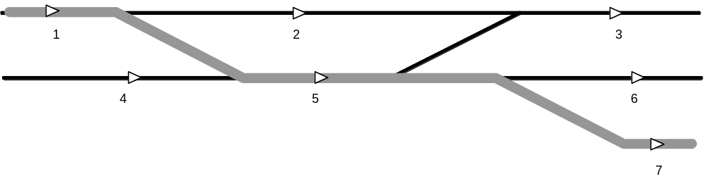Figure 6: Actual route of the train
Figure 7: Route known by the train

The on-board equipment always references its position relative to a balise group, which is then called the Last Relevant Balise Group (LRBG).

Balise groups, which are marked as unlinked, shall never be used as LRBG.

Justification: The location of an unlinked balise group, or the balise group itself, may not be known to the RBC.

Location of Data Transmitted to the On-Board Equipment

Data Transmitted by Balises

All location and profile data transmitted by a balise shall refer to the location reference and orientation of the balise group to which the balise belongs.

Exception: Regarding in-fill information see section 3.6.2.3.1.

Data Transmitted by Radio from RBC

All location and profile data transmitted from the RBC shall refer to the location reference and orientation of the LRBG given in the same message.

For the LRBG the following requirements have to be met:
- The on-board equipment shall use the last balise group passed as a reference when reporting its position to the RBC (in the following termed as LRBG_{ONB}). Only
- balise groups marked as linked and contained in the linking information if linking information is known on-board
or
- the last balise group not marked as unlinked, when no linking is established
shall be regarded.
- The RBC shall use the last relevant balise group which was reported by the on-board equipment as a reference (in the following termed as LRBG_{RBC}). At a certain moment LRBG_{RBC} and LRBG_{ONB} can be different.
- The on-board equipment shall be able to accept information referring to one of at least eight LRBG_{ONB} last reported to the RBC.

Example: The following figure illustrates the on-board and RBC views of LRBGs :
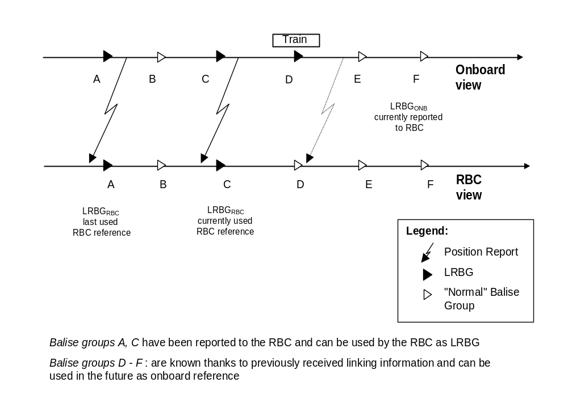
Figure 8: On-board and RBC views of LRBG when train is reporting new LRBG_{ONB} "D"

Data transmitted by In-fill Device

All location and profile data transmitted by an in-fill device shall refer to the location reference of the balise group at the next main signal (identified by the in-fill information) and to the orientation given by the in-fill device. (See note after justification).

Justification:

At locations where routes join: In-fill information is the same for all routes, only linking information is different for different routes, see figure below (in-fill by means of balise group(s), loop or radio)

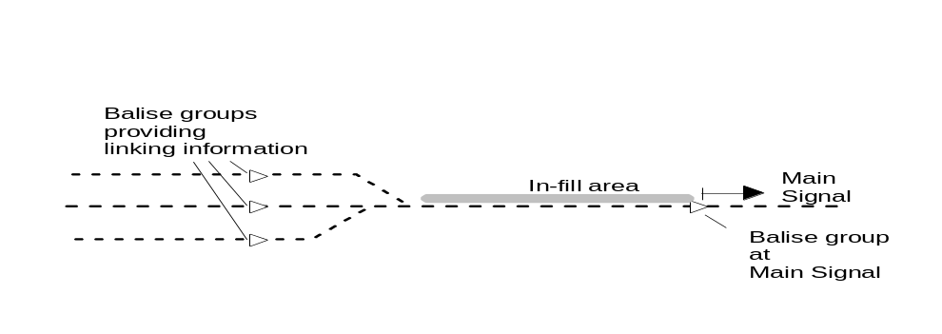
Figure 9: Routes Join in Rear of In-Fill Area

In case of an in-fill area with multiple balise groups: all balise groups transmit identical information, as the information of all groups refers to the balise group at the main signal.

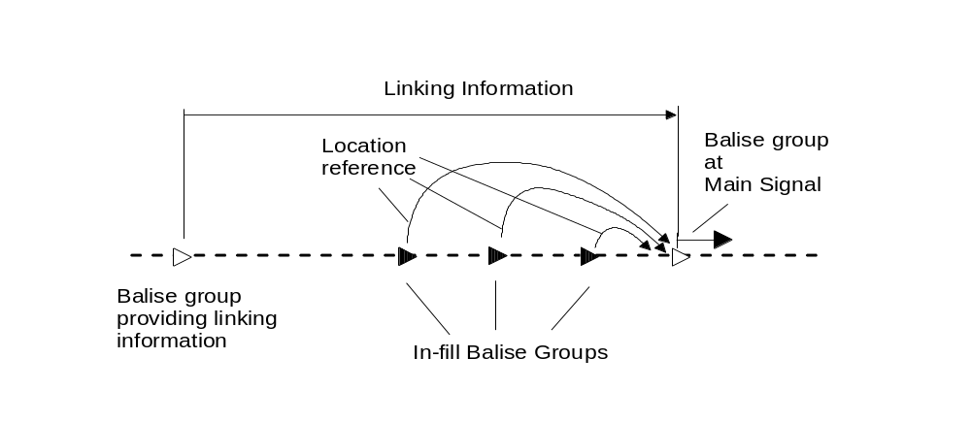
Figure 10: Location referencing of in-fill device balise groups

Note:The orientation given by the in-fill device is (see section 3.9):

In case of a balise group, the orientation of the balise group sending the in-fill information

In case of loop, the orientation indicated by the End Of Loop Marker

In case of radio, the orientation of the LRBG indicated in the message

Validity direction of transmitted Information
FRS reference: - none

General

The direction for which transmitted information is valid shall refer to:
- the direction of the LRBG for information sent by radio
- the direction of the balise group sending the information.

Data transmitted to the on-board equipment (by balise or radio) shall be identified as being valid for
- both directions
- the nominal direction
- the reverse direction
of the referenced balise group.

Deleted .

When receiving information from any transmission medium, the on-board equipment shall only take into account information valid for its orientation. Other information shall be ignored. Exception: for SL and SH engines, balise group crossing direction shall be considered.

If the train orientation is unknown, data received from any transmission medium valid for one direction only (nominal or reverse) shall be rejected by the onboard equipment. Data valid for both directions shall be evaluated (see section 4.8).

If no co-ordinate system has been assigned to a single balise group, data transmitted by that balise group requiring the co-ordinate system to be known, i.e. all data which are only valid for one direction (nominal or reverse) shall be rejected by the on-board system.

Note: In case the balise group at a main signal at danger is equipped with a single balise group and the balise group is passed before the co-ordinate system has been assigned, the train will not be tripped.

Figure 11: Intentionally deleted

Location , Continuous Profile Data and Non-continuous Profile Data

Location and profile data shall have the structure shown in Figure 12 below

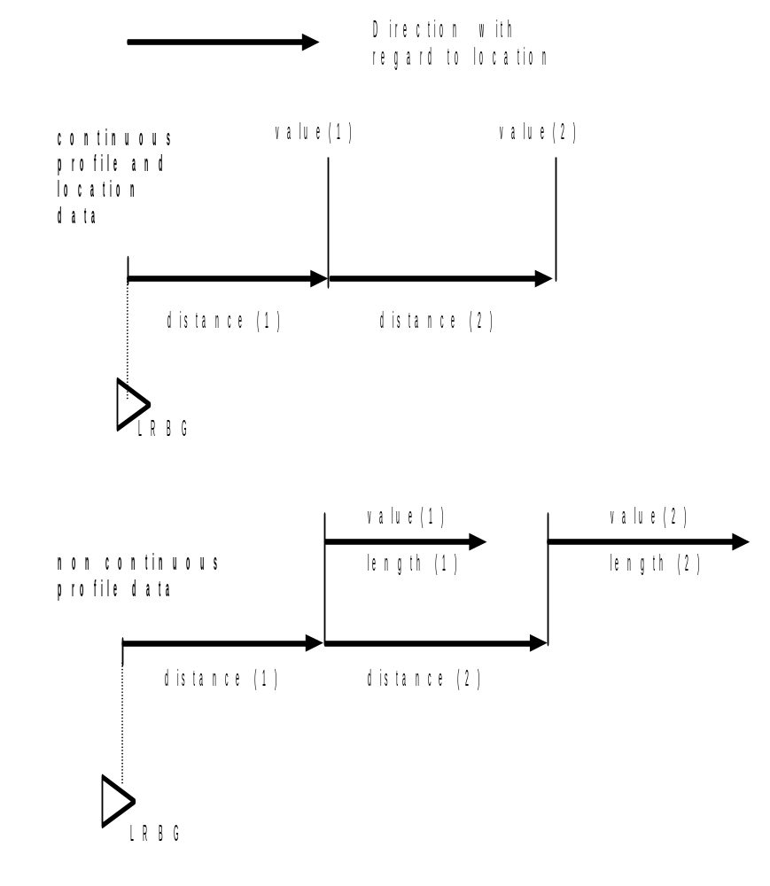
Figure 12: General Structure of location and profile data

With regard to Figure 12 the following applies to continuous profile data:
- Value (n) shall be valid for distance (n+1)
- For distance (1) the previously received data shall be used (in case of an SSP this includes train length delay, refer to 3.11.3.1.3).
- Distances shall be given as unsigned incremental values representing the distance between value(n) and value(n-1).
- The last value (n) transmitted shall be valid for an unlimited distance unless value(n) represents a special "end of profile" value.

With regard to Figure 12 the following shall apply to location data:
- Distances shall be given as unsigned incremental values representing the distance between value(n) and value(n-1).
- For distance (1) the previously received data shall be used.
- Each value (n) may represent a single value or a set of data .

According to Figure 12 the structure for non-continuous profile data shall allow to contain multiple elements ( value(n) for length(n) ) inside the profile.
- Distance to the start of each element (value(n) for length(n)) shall be given as unsigned incremental values, each increment representing the distance between starts of element (n) and element (n-1).
- For distance (1) the previously received data (or initial data/default values, see section 3.7) shall be used.
- Each value (n) may represent a single value or a set of data.
- Note: There is no relationship between length of element (n-1) and distance (n), i.e., elements may overlap.

It shall be possible to shift the location reference from the RBC when the train has changed its train orientation or running direction.

Justification: Refer to Figure 13. To make it possible to shift the location reference if – due to the location of the LRBG and the start location – distance (1) would become a negative value.
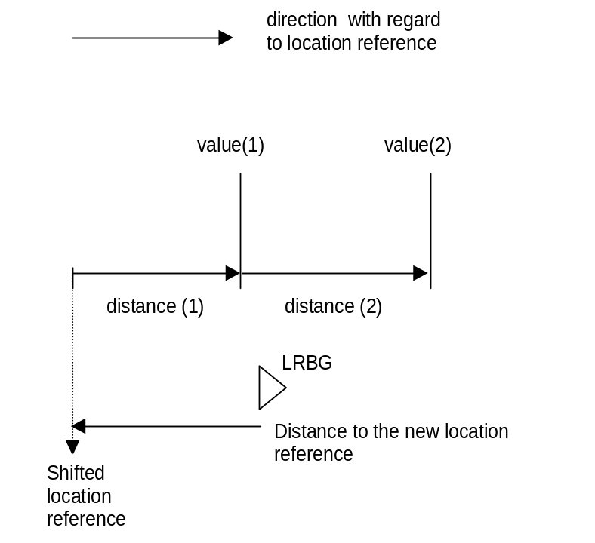
Figure 13: Shifted Location Reference (shown for continuous data /location profile, but also valid for non continuous data profile).

With regards to Figure 12 the following applies to linking information
- The distance (1) shall be given to the first balise group included in the linking information
- The distance (n) shall be given as the distance between two consecutive balise groups
- Each value (n) shall represent the linking information related to that balise group.

Train Position Confidence Interval

All location related information transmitted from trackside equipment shall be used by the on-board equipment taking into account the confidence interval to the train position, if required for safe operation.

The confidence interval to the train position shall refer to the distance to the LRBG and shall take into account
- On-board tolerances (determining the balise group location reference, odometer accuracy)
- The location accuracy of the LRBG.

Distance information received from trackside shall be evaluated on-board as nominal information, tolerances shall be taken into account only for the location accuracy of the location reference.

Note: The confidence interval increases in relation to the distance travelled from the last location reference depending on the accuracy of odometer equipment.

The confidence interval shall be reset taking the location accuracy into account, when the next linked balise group has been read.

The value of the Location Accuracy shall be determined by Linking information if available, if not, by a fixed value (see Appendix A3.1).
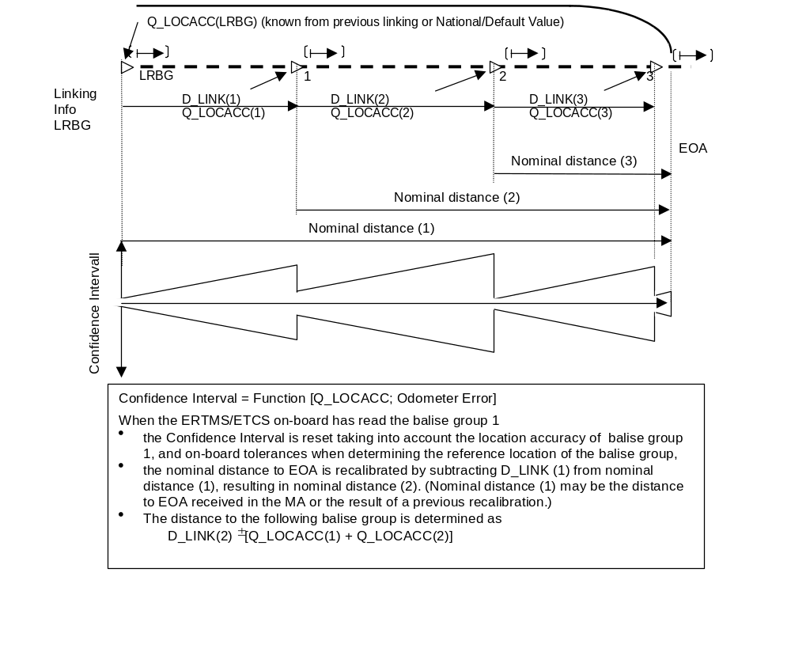
Figure 13a: Position Reference Evaluation

The train front end position shall be identified in the following way
- The estimated front end position.
- The max(imum) safe front end position, differing from the estimated position by the under-reading error according to the actual confidence interval.
I.e. in relation to the orientation of the train this position is in advance of the estimated position.
- The min(imum) safe front end position, differing from the estimated position by the over-reading error according to the actual confidence interval.
I.e. in relation to the orientation of the train this position is in rear of the estimated position.

Note: The rear end position is referenced in the same way. However min safe rear end is only safe if sent together with train integrity information.

If the train position has been adjusted (on passing a linked balise group) a certain location may be passed twice, or never. The on-board equipment shall ensure that an order related to this location is executed once.

The estimated front end shall be used when supervising location information, unless stated otherwise.

Position Report (Level 2/3 only)

General

The position shall refer to the front end of the respective engine with regards to the train orientation.

Note: The orientation of the train defines on which side of the train the active desk is in reference to the LRBG orientation. The orientation of the train cannot be affected by the direction controller position. If no desk is active the train reports the orientation as when a desk was latest active.

The position report shall contain at least the following position and direction data
- The distance between the LRBG and the estimated front end of the train.
- The confidence interval to this distance identifying the over-reading /under-reading amount.
- The identity of the location reference, the LRBG.
- The orientation of the train in relation to the LRBG orientation.
Note: Driver selected running direction is only handled by the on-board system.
- The position of the front end of the train in relation to the LRBG (nominal or reverse side of the LRBG).
- Train speed
- Train integrity information.
- Direction of train movement in relation to the LRBG orientation.
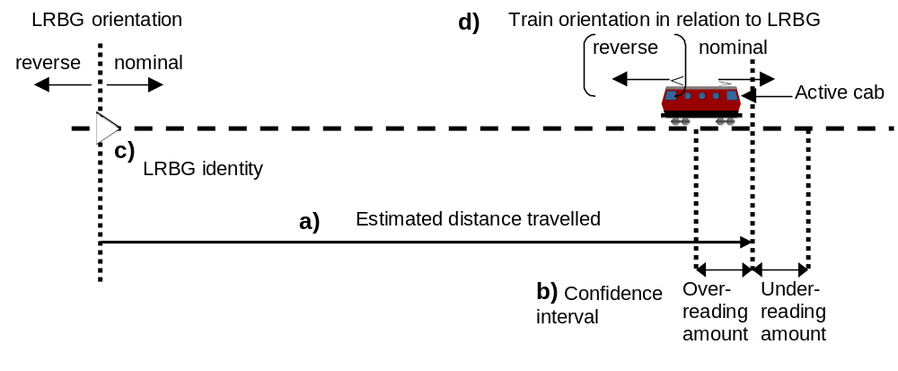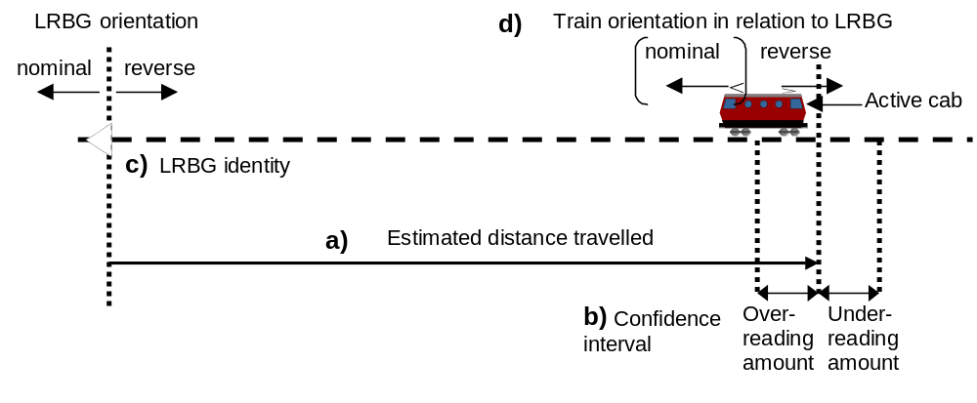
Figure 14: Information given in a position report (two examples to show the relation between LRBG and train orientation)

In case the LRBG is a single balise group and its orientation is unknown, a special position report shall be used reporting in addition the previously read balise group (refer to section 3.4.2.3.3.1). The train shall only combine two single balises in a position report if the train has not changed its orientation between reading the two balise groups.
Information contained in the position report shall be given in relation to the train orientation (from the previous balise group towards the LRBG).

The on-board equipment shall report its train position, if at least one of the conditions listed hereafter is met:
- When reaching standstill, if applicable to the current mode.
- On executing a mode change.
- When the driver has entered train integrity information.
- If loss of train integrity has been detected.
- When the train has passed a RBC/RBC border with its min safe rear end.
- If the train has changed its orientation (operational requirement: already covered by mode change in b) above).
- On executing a level transition.
- Following the successful establishment of a communication session.
- As requested by the RBC specified in the position report parameters.
- If no position report parameters have been given from the RBC or if they have been deleted, the on-board equipment shall report the train position at every balise group passage.
- When the train has passed a RBC/RBC border with its max safe front end.

For the position report parameters requested by the RBC the following possibilities shall be available, individually or in combination
- Periodically in time.
- Periodically in space.
- When the max safe front end or min safe rear end of the train has passed a specified location.
- At every balise group passage.
- Immediately.

Note: d) and e) can not be combined.

Deleted.

The given position report parameters shall be valid until new parameters are given from the RBC.

The mode and level reported in a position report shall be consistent (e.g., no mode that relates to the previous level).

Report of Train Rear End Position for Level 3

Train integrity information shall be given by external device or by driver.

Driver input of train integrity shall only be permitted at standstill.

The train integrity information shall consist of
- Train integrity status information
- No train integrity information
- Train integrity information confirmed by integrity monitoring device
- Train integrity information confirmed (entered) by driver
- Train integrity lost
- Safe train length information (only valid if train integrity is confirmed at the same time).

The safe train length information shall represent the distance between the min safe rear end (by subtracting the train length from the min. safe front end position at the time when integrity was established last time) and the estimated position of the train front.

The safe train length information shall be re-calculated for every position report using the same last value of min safe rear end position until a new min safe rear end position is established on-board taking into account the time to detect train integrity.

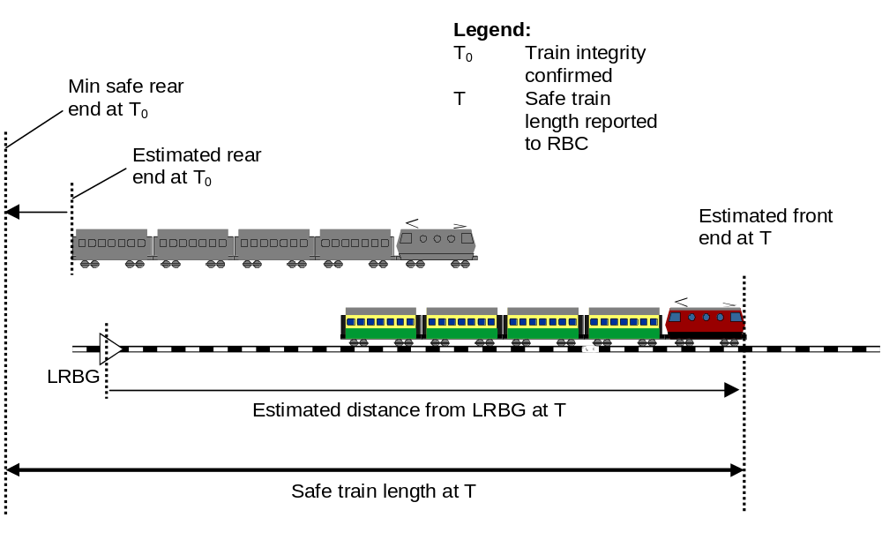
Figure 15: Calculation of Safe Train Length when train integrity was established

Geographical position reporting
FRS reference: 4.7.3 – Geographical Position of the Train

The on-board equipment shall, on request from the driver, be capable of displaying to the driver the geographical position of the estimated front end of a train in relation to the track kilometre.

The resolution of the position indication shall be 1 metre (sufficient to allow the driver to report the train position when communicating with the signalman).

If information is received both over radio and from balise groups the latest information received shall always be used.

The information shall always use a balise group as geographical position reference balise group and if needed an offset from that balise group.

The announced and not used geographical references shall be deleted on-board if the train changes orientation.

The track kilometre value given for a geographical reference location shall be used after having travelled the offset distance (if not zero) from the related geographical reference balise group.

The distance travelled from the reference shall be taken into account when calculating the geographical position.

In cases where the track kilometre is not incremental (jumps, changes in counting direction, scaling error) the reported position might be wrong between the point of irregularity and the next new reference.

In cases where single balise groups are used to give geographical position information and where no linking information is available (and therefore no orientation can be assigned to the balise), the on-board equipment shall indicate to the driver the track kilometre of the balise and the distance between that balise and the estimated front end of the train as separate values.

Offset shall be set to zero by the trackside when geographical information is given using single balise groups.

The on-board equipment shall continue calculating the position from a reference unless it is told not to do so or unless a maximum distance D_{GEO} expires.

The following data shall be included in a message for geographical position (for every track kilometre reference):
- Distance from geographical position reference balise group to the track kilometre reference (offset)
- Value of the track kilometre reference
- Counting direction of the track kilometre in relation to the geographical position reference balise group orientation.
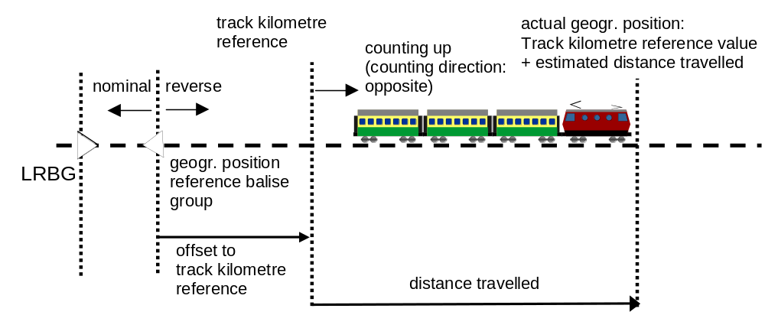
Figure 16: Geographical position example

Completeness of data for safe train movement

Completeness of data

To control the train movement in an ERTMS/ETCS based system the ERTMS/ETCS on-board equipment shall be given information from the trackside system both concerning the route set for the train and the track description for that route. The following information shall be given from the trackside
- Permission and distance to run, the Movement Authority (MA) (see section 3.8)
- When needed, limitations related to the movement authority, i.e. Mode profile for On Sight or Shunting and signalling related speed restriction (see sections 3.12.4 and 3.11.6). Mode profile and Signalling related Speed restriction shall always be sent together with the MA to which the information belongs
- Track description covering as a minimum the whole distance defined by the MA. Track description includes the following information
- Speed limitations, the Static Speed Profile (SSP) (see section 3.11.3).
- The gradient profile (see section 3.11.10).
- Optionally Axle load Speed Profile (ASP) (see section 3.11.4)
- Optionally track conditions (see section 3.12.1).
- Optionally route suitability data (see section 3.12.2).
- Optionally areas where reversing is permitted (see section 3.15.4).
- Optionally changed adhesion factor (see section 3.18.4.6).
- Linking information when available.

Responsibility for completeness of information

The Movement Authority (MA) shall be given to the on-board equipment
- Together with the other information ( as listed in section 3.7.1.1 c) and d))
or
- Separately, if the other information has already been correctly received by the on-board equipment.

The trackside shall be responsible for that the on-board equipment has received the information valid for the distance covered by the Movement Authority.

The MA and the related mode profile, if any, shall not be accepted by the on-board equipment if the SSP and gradient already available on-board or given together with the MA do not cover the full length of the MA.

It shall be the responsibility of the trackside to send additional information when needed. The information referred to is
- Emergency messages (from RBC only)
- Request to stop earlier (from RBC only)
- Temporary speed restrictions
- National values
- Level transition information

Extension, replacement of track description and linking information

New track description and linking information shall replace (in the on-board equipment) previously received track description and linking information from the start location for the new data.

Note: This is also valid at level transitions or RBC-RBC hand-over, i.e. new information valid for a distance beyond the border also replaces the one previously received if covering the same distance.

Note: For linking information the start location of the new data is the LRBG.

It shall be possible to resume initial states (for each type of track description except SSP and gradient) by sending a track description (separate for each type) only stating that all data shall resume the initial state at a defined location. (For initial states see the related sections referenced in section 3.7.1.1).

Track description and linking information shall be deleted (or initial state shall be resumed) in the on-board equipment in the following situations
- If the MA has been replaced by a shorter one or shortened due to time out. The information beyond the new End of Authority (or danger point/overlap if given) shall be deleted.
- If an Emergency Stop message has been sent from the RBC and taken into account by the on-board equipment. The information beyond the new stop location shall be deleted. The MA shall be withdrawn to the new stop location.
- In case the train has changed its orientation also the MA shall be deleted (operational requirement: will be executed due to the mode change).
- In case the Train Data regarding train category, axle load, loading gauge or power supply has been changed by the driver or by the on-board equipment, the MA and track description shall be withdrawn to the current position of the train.

The on-board equipment shall inform the RBC when track description data has been deleted (level 2/3).

Deleted.

Note: regarding the handling of Temporary Speed Restrictions see section 3.11.5.

Movement authority
FRS reference: 4.2.2 – End of Movement Authority, 4.3.3 – Release Speed Calculation, 4.3.7 – Supervision of movement authorities and speed limits

Characteristics of a MA

The following characteristics can be used in a Movement Authority (see Figure 17: Structure of an MA):
- The End Of Authority (EOA) is the location to which the train is authorised to move.
- The Target Speed at the EOA is the permitted speed at the EOA; when the target speed is not zero, the EOA is called the Limit of Authority (LOA). This target speed can be time limited.
- If no overlap exists, the Danger Point is a location beyond the EOA that can be reached by the front end of the train without a risk for a hazardous situation.
- The end of an overlap (if used in the existing interlocking system) is a location beyond the Danger Point that can be reached by the front end of the train without a risk for a hazardous situation. This additional distance is only valid for a defined time.
- A release speed is a speed under which the train is allowed to run in the vicinity of the EOA, when the target speed is zero. One release speed can be associated with the Danger Point, and another one with the overlap. Release speed can also be calculated on-board the train (see section 3.13.7).
- The MA can be split into several sections, The last one is called End Section.
- A first time out value can be attached to each section. This value will be used for the revocation of the associated route when the train has not entered into it yet. It is called the Section time-out.
- In addition, a second time out value can be attached to the End Section of the MA. This second time out will be used for the revocation of the last section when it is occupied by the train; it is called the End Section time-out.

The values of the time-outs possibly given in an MA shall take into account the time elapsed from the start of validity of information to the sending of the message.

Note: A Danger Point can be (not exhaustive list):
- the entry point of an occupied block section (if the line is operated according to fixed block principles)
- the position of the safe rear end of a train (if the line is operated according to moving block principles)
- the fouling point of a switch, positioned for a route, conflicting with the current direction of movement of the train (both for fixed and moving block mode of operation)

Note: Traditionally the overlap is a piece of track (beyond the danger point), that is put at disposal of a train, to guarantee a non hazardous situation, also in case the driver should misjudge the stopping distance for the train. In ERTMS/ETCS the overlap can be used to improve the efficiency of the braking supervision.

Note: Time-out values can be given in the MA to cope with the following situations depending on the interlocking operations, i.e. the timers on-board will only reflect the situation trackside and when expired (on-board) the actions taken are restrictive:
- Section time-out or time-out for the speed at the EOA/LOA: When a signalman requests a route release of a part of a route not yet entered by the approaching train.
- End Section time-out: When the train has entered the last part of a route, the automatic route release can be delayed to make sure that the train has come to a standstill before any switches inside the route can be moved.
- Time-out for an overlap: When the train has entered the last part of a route, the overlap associated with the route remains valid for a certain time to make sure that the train has successfully stopped before its end of authority. If the overlap is still unoccupied when the timer expires the interlocking revokes the overlap.

Note: If the trackside equipment does not have enough information to give the distance to End Of Authority (with target speed equal to zero) a target speed higher than zero can be given (speed at LOA, Limit Of Authority). It is the responsibility of the trackside to ensure that the safe distance beyond the EOA/LOA is long enough to brake the train from the target speed to a stand still without any hazardous situation. It is the responsibility of the on-board equipment to apply the brakes if no new information is received when the Limit of Authority is passed.

MA request to the RBC

It shall be possible for the on-board equipment to request a new Movement Authority from the RBC.

The parameters for requesting a new MA shall be given by the RBC.

In level 2/3, the following possibilities shall be available:
- A defined time before the train reaches the indication limit (see section 3.13) for the EOA/LOA assuming it is running at the warning speed.
- A defined time before the timer for any section of the MA expires.

It shall be possible to define whether the MA request shall be repeated until a new MA is received or not and if so, the time between each repetition.

The given data shall be valid until new MA request parameters are given from the RBC.

In case the MA request must be repeated and no MA request parameters have been sent from the RBC, the repetition cycle shall be according to the fixed value (see appendix).

In level 2/3: an MA request shall be sent to the RBC when the driver selects start. (See Chapter 5).

In level 0,1,STM: if a level 2/3 transition is announced and a communication session is already established, an MA request shall be sent to the RBC when the information "Track ahead free up to level 2/3 transition location" is received from balise group.

In level 0,1,STM: the ERTMS/ETCS on-board equipment shall also inform the RBC about the identity of the level 2/3 transition location balise group, as received through the information "Track ahead free up to level 2/3 transition location".

Together with the MA request the on-board shall inform the RBC if the track description has been deleted.

Structure of a Movement Authority (MA)

The distance to End of Authority (EOA) can be composed of several sections.

For each section composing the MA the following information shall be given;
- Length of the section
- Optionally, Section time-out value and distance from beginning of section to Section Time-out stop location

In addition, the End section of the MA may include;
- End Section Time-out value and distance from the End Section Time-out start location to the end of the last section
- Danger point information (distance from end of section to danger point, release speed related to danger point)
- Overlap information (distance from end of section to end of overlap, time-out, distance from overlap time-out start location to end of section, release speed related to overlap)

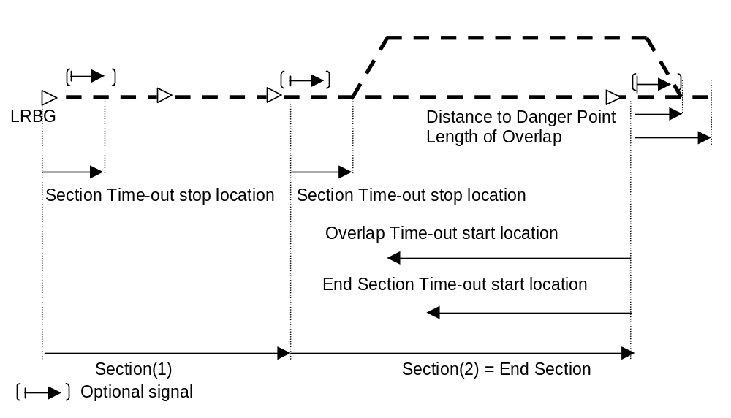
Figure 17: Structure of an MA

Note: If only one section is given in the MA it is regarded as the End Section.

The time-out start locations (for Overlap and End Section) and the Section Time-out stop location shall be inside of the corresponding section.

In level 3, no time-outs shall be used.

Note: For level 3 functionality the split of responsibility between the RBC and the Interlocking has to be considered. Time out of routes and related overlap can not be based on train position reports since the position report can be delayed compared to the real position of the train. The route release and revocation of routes can not be carried out by the interlocking until permitted by the RBC.

When an MA is transmitted by a balise group, the length of the first section shall refer to the balise co-ordinate system of that balise group.

In case a main signal is at danger in level 1, the first section shall give the distance from the balise group at the main signal to the location of the main signal, i.e. the distance to EOA is given. Where available, information concerning danger point and overlap for this EOA may also be given.

Justification: The balise group is not necessarily placed at the same location as the signal and thus an in-fill message (which includes the same information as the balise group at the main signal) could change the location of the EOA to a position closer to the train.

In case the main signal is at danger in level 1, the on-board shall supervise the given distance (specified in section 3.8.3.7) as the distance to EOA.

When an MA is transmitted by radio from the RBC, the length of the first section shall refer to the balise co-ordinate system of the LRBG given in the same message.

It shall be possible to give the length of a section to any location in the track.

Note: A section can cover several blocks and is not restricted to block ends (see figures).
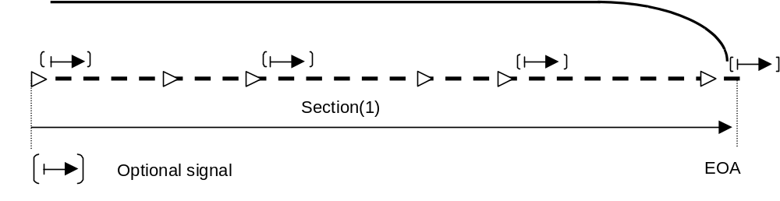
Figure 18: Distance to End Of Authority when no time-outs are needed

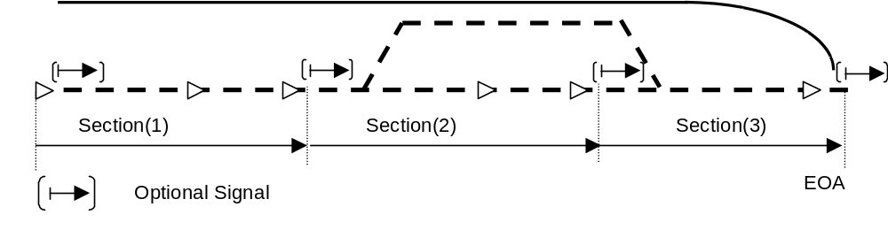
Figure 19 : Distance to End Of Authority when time-outs might be needed

In moving block operation the MA shall never exceed the min safe rear end of the preceding train.
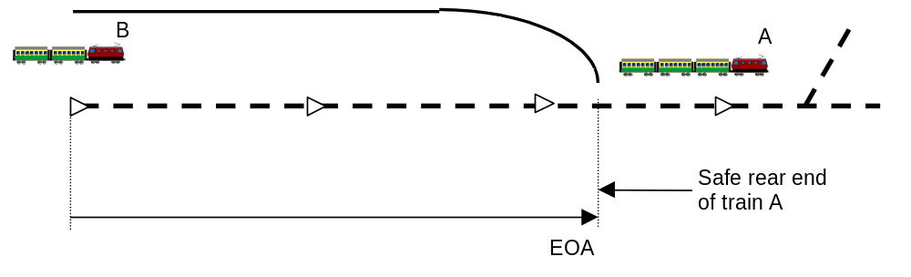
Figure 20: MA in moving block operation.

Use of the MA on board the train

End Section Time Out

The End Section timer shall be started on-board when the train passes the End Section timer start location given by trackside with its max safe front end.

The EoA/LoA shall be considered to be withdrawn to the current position of the train when the time out has expired and a non zero target speed value at the EOA/LOA shall be set to zero.

Section Time Outs

The on-board shall start a Section timer for each section:
- For Level 2: at the value of the time stamp of the message including the MA.
- For Level 1: at the time of passage over the first encountered balise of the balise group giving the MA.

Justification for b): This is to ensure that the timer is always started before or at the same time as the related variable information is received. Thus the timer start is independent of in which balise the variable information is given.

When the time out has expired, the following shall apply:
- the EoA/LoA shall be withdrawn to the entry point of the revoked section, the National/ Default Value of the Release Speed shall apply ;
- if any, a non zero target speed value at the EoA/LoA shall be set to zero.

Note: This may lead to immediate brake intervention (emergency or service brake depending on the train speed related to the brake supervision).

The Section timer shall be stopped when the min safe front end of the train has passed the associated Section Time-out stop location.

Time-out of the speed associated with the EOA/LOA

The on-board shall start a timer for the speed at the EOA/LOA:
- For Level 2: at the value of the time stamp of the message including the MA.
- For Level 1: at the time of passage over the first encountered balise of the balise group giving the MA.

When the time out has expired, the speed value shall be set to zero, i.e. the Limit of Authority becomes an End of Authority.

Time-out of Overlap

The overlap timer shall be started on-board when the train passes the overlap timer start location given by trackside with its max safe front end.

When the timer expires, the overlap shall be considered as released. I.e. the Supervised Location is withdrawn to the Danger Point (if any) or to the EOA.

When the train has passed the overlap timer start location and the train has come to standstill, the overlap shall be considered as released, even if the time-out has not yet expired.

Supervised Location

The Supervised Location, SvL shall be defined on board as;
- the end of overlap (if any and before time-out).
- if not, the Danger Point (if any).
- if not, the End Of Authority.

In-fill MA (level 1 only)

An MA given by an in-fill device is called an in-fill MA.

An in-fill MA shall be evaluated on-board only if the on-board equipment is in FS mode.

The in-fill information shall include the identity of the balise group at the next main signal i.e. the identity of the balise group giving the information that is repeated by the in-fill device.

An in-fill MA shall be evaluated on-board only if the linking information, regarding the main signal balise group to which it refers, is available.

The on-board shall start a Section timer for each section beyond the next main signal:
- When the in-fill information is received from a balise group at the time of passing the first encountered balise of the in-fill balise group.
- When the in-fill information is received from a loop at the time of receiving the loop message.
- When the in-fill information is received from a radio in-fill unit at the value of the time stamp of the radio in-fill message including the MA.

MA Update and Extension

A new MA shall always replace the one previously received:
- When the MA is given from a balise group at a main signal (i.e. not in-fill information) or from the RBC all data included in the previous MA shall be replaced by the new data.
- When the MA is given as in-fill information all data beyond the announced balise group at the next main signal shall be replaced.

Note: This refers to all information included in the MA as listed in section 3.8.1.1 and the Signalling related speed restriction (see section 3.11.6).

It shall be possible to update the length of the current section by means of repositioning information (see section 3.8.5.3).

Note: The current section need not be the end section.

Repositioning information contained in a balise group message shall only be evaluated if linking information has announced a following balise group as unknown but containing repositioning information.

A balise group message containing a movement authority shall not contain repositioning information for the same direction.

Note: It is possible to combine repositioning with an in-fill MA.

Examples of MA extension

Note: In the following examples on how to extend an MA are given. The examples are not exhaustive.

Example: Extension of MA via main balise group in Level 1
- By giving a new longer section or
- By giving two or more sections or
- By giving a first section to the same location as in the previous MA and a second section
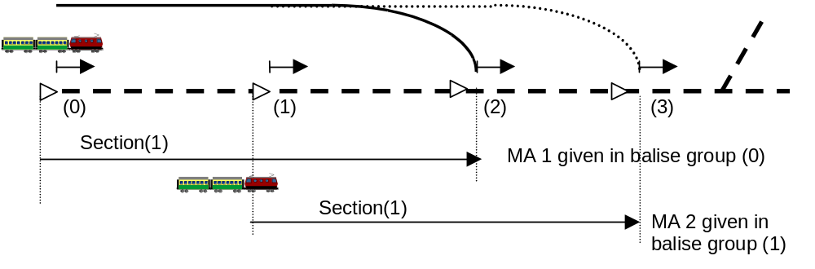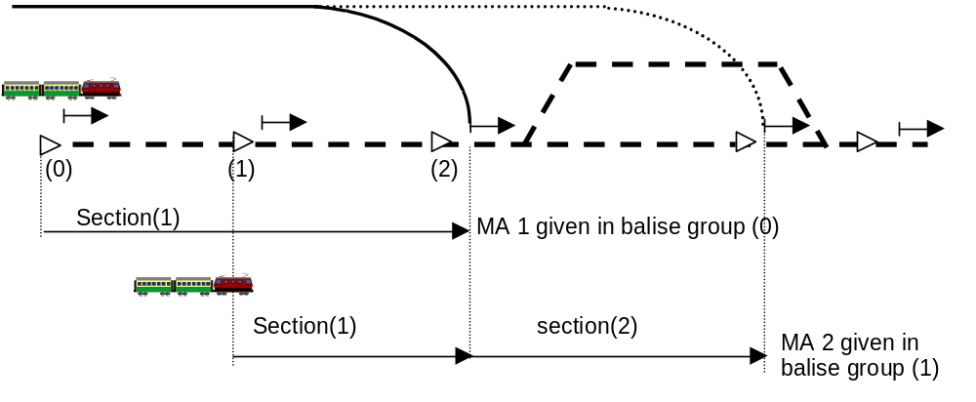
Figure 21: Extension of MA via a balise group at the main signal

Example: Extension of MA via in-fill devices in Level 1. (Refer to section 3.6.2.3 for location reference given by in-fill devices)
- By giving a new section, Section (2)

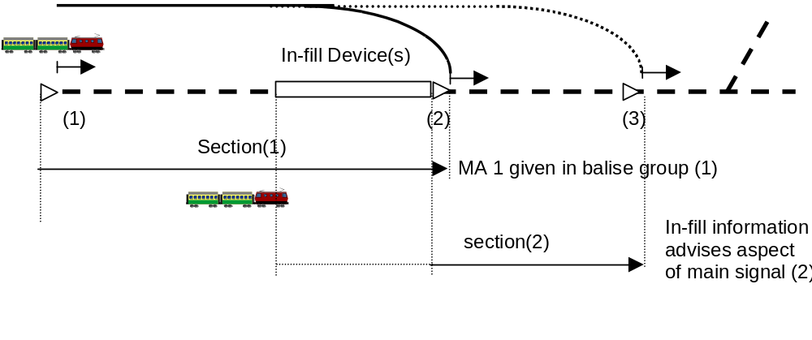

Figure 22: Extension of MA via In-fill Devices

Example: Extension of MA in Levels 2 and 3 by using the same LRBG as in previous MA or a new LRBG.
- Giving a new section
or
- Giving two or more sections
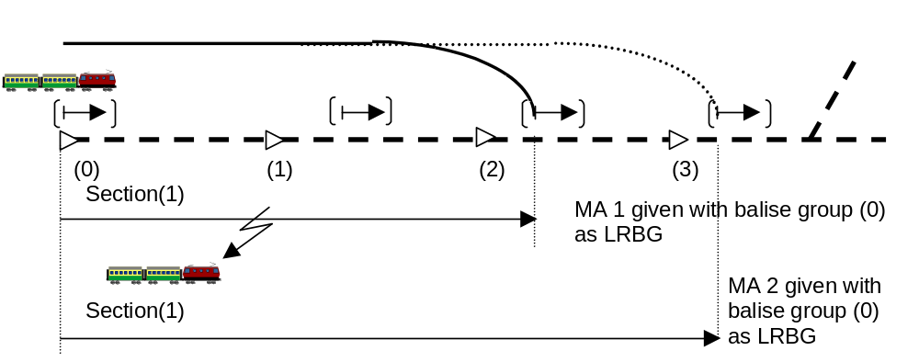
Figure 23: Extension of MA via radio

Example: Extension of MA in level 1 using a balise group containing repositioning information.

Note: In some existing systems, information about the locked route is not complete.

History of the situation (refer to the figure below) :
- Signal A gives an aspect to proceed up to signal Cx because it has received information about the locked route.
- Signal A can determine whether track 3 or track 1 / 2 is locked but is unable to distinguish between track 1 and 2.
- In the situation described the route is set to track 1 or 2.

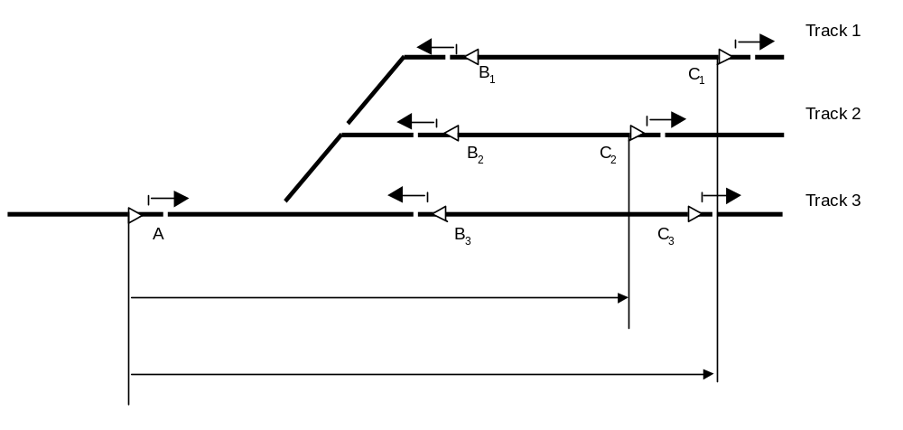
Figure 24: Information on set route not complete at signal A

In balise group A the following information is given:
- The most restrictive track description from all routes (which could be a combination from the routes);
- The linking distance given to the farthest balise group containing repositioning information, the identification of the repositioning balise group is not known;
- For a given aspect of signal A, the most restrictive MA from all routes (the shortest sections from the routes and the lowest target speed at the End Of Authority);
- If some sections are time limited, the most restrictive timer.

Balise groups B (B₁ or B₂) give the following static information:
- This is repositioning information
- Linking to the next balise group C
- The distance to the end of the current section (i.e. the distance to the end of section B1 - C1, or the distance to the end of section B2 - C2)
- The track description related to this track.
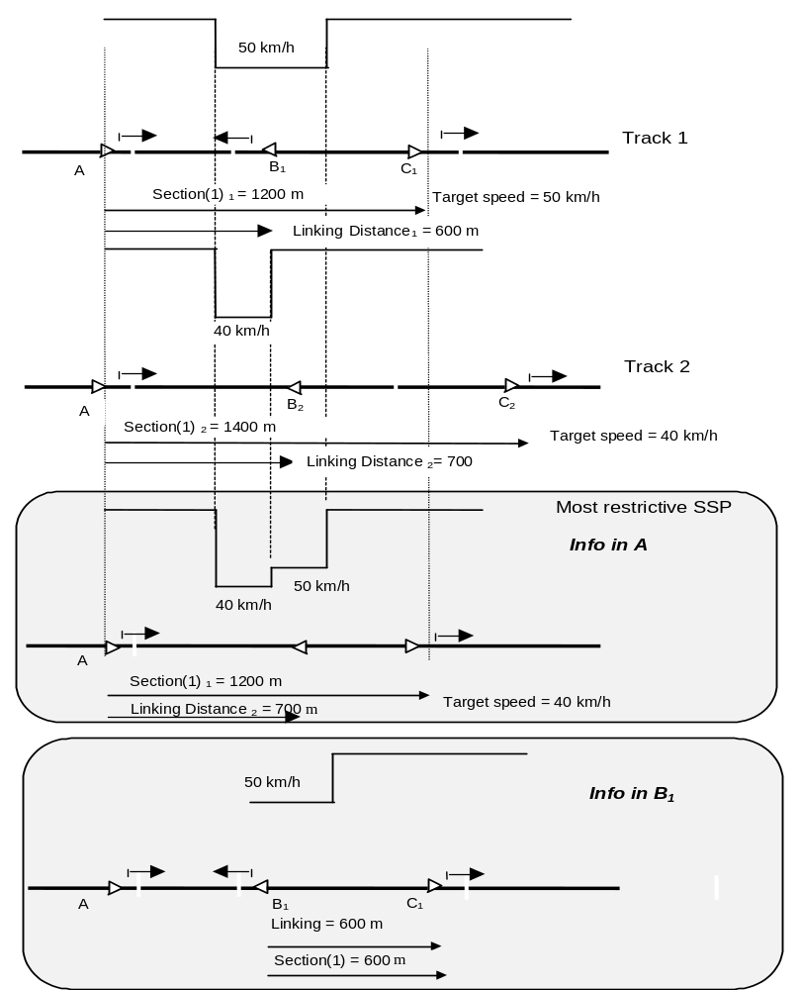
Figure 25: Information contained in A and B₁ (for clarity purposes, only SSPs are drawn but the procedure has to be applied for all track description)

Co-operative shortening of MA (Level 2 and 3 only)
FRS reference: 11.7.1 – Revocation of Movement Authority

It shall be possible to shorten a given MA using a special procedure between on-board equipment and RBC. The procedure is as follows:
- RBC requests (proposes) a new end of authority together optionally with danger point and overlap information at a location closer to the train than the current End of Authority.
- The ERTMS/ETCS on-board equipment checks if the train can be stopped without brake intervention at the requested location.
- If this is possible, the on-board equipment shall accept the new end of authority.
- If not possible, the request is rejected and the previously received MA remains valid
- The RBC shall be informed about the decision.

If the request from the RBC is granted by the on-board, the track description and linking information beyond the new End of Authority (or danger point/overlap if given in the new MA) shall be deleted by the on-board equipment.

Means to transmit In-fill information (Level 1 only)
FRS reference: 4.3.3.5 – Release speed calculation

General

It shall be possible to transmit in-fill information to the on-board equipment using
- Balise groups
- Euroloops
- Radio in-fill units.

The principle used for the in-fill information shall be the same independent of transmission media.

If the on-board system is not equipped with the in-fill transmission media as requested by the announcement balise group, the announcement information shall be ignored by the on-board equipment and the train shall proceed according to the previously received information.

Note: No additional description is needed for in-fill by balise group (other than already covered in previous chapters).

In-fill by loop

An End Of Loop Marker (EOLM) is by definition a device to mark the beginning or the end of a loop. When receiving this information, the on-board equipment knows that it is entering/leaving a track equipped with a loop. In unidirectional applications it shall be possible to have an EOLM only at the entry side of a loop.

Balise groups shall be used as EOLMs. They act as an EOLM by sending the EOLM information to the passing train.

EOLMs have an orientation that is identical to the balise group orientation. The general rules for balise orientation therefore also apply to EOLMs.

EOLM information might be contained in a balise group that contains other information.

The EOLM shall send the identity of the announced loop.

The on-board shall only accept information coming from the loop with the announced identity.

Deleted.

Deleted.

The following information shall be sent in advance by the EOLM to prepare for reception of the loop information:
- Loop identity used to identify the loop.
- Key to select the spread spectrum key necessary to receive the loop telegrams.
- Distance to the loop giving the distance from the EOLM to the location from where on loop messages can be received.
- Length of the loop giving the length of the loop over which messages can be received.
- Indicator telling the on-board whether the orientation of the loop is identical or reverse to the orientation of the announcing EOLM.

The on-board shall be prepared to receive messages from the Euroloop after passing the EOLM.

When the on-board equipment reads the next main signal balise group or when it detects that the next main signal balise group was missed, new in-fill information possibly received from the loop shall be ignored.

The distances given in an EOLM (distance to loop, length of loop) are used for diagnostic purpose only. They shall therefore not be used to restrict reception of loop telegrams to specific locations.

In-fill by radio

In level 1 areas it shall be possible to send to the on-board equipment orders to establish/terminate a communication session with a radio in-fill unit.

The orders shall be sent via balise groups.

The order to establish a communication session shall be ignored:
- If the on-board equipment is not in Full Supervision.
- If the on-board equipment does not include radio.

If the on-board equipment includes radio, the communication session shall be established using the same protocols and interfaces as for Level 2/3 operations.

If the order to establish a communication session with a radio in-fill unit is received by an on-board equipment, connected with another radio in-fill unit, the existing communication session shall be terminated and the new one shall be established.

Intentionally deleted.

A Radio In-fill Unit shall not initiate a communication session with an on-board equipment.

The order to establish/terminate a communication session shall be sent together with the following radio in-fill area information:
- Location where to perform the action (referred to the balise group containing the order).
- Next main signal balise group identifier (only if the action is Establish communication session).

The establishment of a communication session for radio in-fill shall not change the operational level of the on-board i.e. the information in the balise group shall be taken into account as usual in level 1.

The on-board equipment shall inform the radio in-fill unit
- As soon as the location indicated in the order is passed (i.e. entry of the train in the in-fill area)
- As soon as the next main balise indicated in the order is read or the on-board equipment detects that it was missed.

The information sent to the radio in-fill unit by the on-board equipment shall include
- Train identity (ETCS-ID of the on-board equipment)
- Train location (using as LRBG the balise group, where the order to contact the radio in-fill unit was found)
- Identifier of the next main signal balise group
- Time stamp

Justification:
- The train identity is used for conformity with other train to track messages
- The identifier of the next main signal balise group allows the radio in-fill unit to identify safely where the train is going, even in the case of a points area

As soon as the radio in-fill unit is informed that a train has entered an in-fill area, it shall
- Terminate a possible previous sending of in-fill information to the on-board equipment
- Send cyclically the in-fill information corresponding to the message currently sent by the next main signal balise group indicated in the information from the on-board equipment.

Justification: case a) refers to the possibility that a report from the on-board equipment, after having passed the previous main signal, was lost.

The radio in-fill unit shall terminate the sending of in-fill information as soon as information is received, that the on-board equipment has read the next main signal balise group indicated in the order or that the on-board equipment has detected that it was missed.

The radio in-fill unit shall evaluate the time stamp according to the principles of section 3.16.3.2.
The on-board equipment shall check the consistency of radio in-fill data, according to the principles of section 3.16.3.1 and 3.16.3.3.

When the on-board equipment reads the next main signal balise group or when it detects that the next main signal balise group was missed, new in-fill information possibly received shall be ignored.

The on-board equipment shall terminate the communication session according to the orders received from the trackside (balise group).

In case of accidental disconnection, the on-board shall terminate the attempts to set-up again a safe connection with the radio in-fill unit as soon as the location indicated in the order for the disconnection is reached.

Emergency Messages

General
FRS references: 4.6.4 – Emergency stop to train

Emergency messages shall be sent individually to each on-board equipment, either as high priority data or as normal priority data of the same radio connection, as described in Euroradio specification. Only emergency messages can be sent as high priority data, not their acknowledgement or their revocation.

Justification: In case of hazardous events, it is possible to use high priority data in the radio link between RBC and on-board equipment to get a quick reaction.

An emergency message shall contain an identifier decided by the trackside.

The same identifier shall be used in case the emergency message is repeated. If the on-board receives a new message with the same identifier it shall replace the previous one.

Each emergency message to an on-board equipment shall be acknowledged, using the corresponding emergency message identification number.

Note: This acknowledgement informs the RBC about the use of the emergency message by on-board equipment and is independent from the general acknowledgement for track-to-train messages, as specified in section 3.16.3.5."

Emergency Stop

It shall be possible to stop a train with a conditional or an unconditional emergency stop message.

A conditional emergency stop message shall contain the information of a new stop location, referred to the LRBG.
In case, when receiving this message
- the train has already passed with its min safe front end the new stop location, the emergency stop message shall be ignored and the RBC and the driver shall be informed.
- the train has not yet passed with its min safe front end the new stop location, the emergency stop message shall be accepted, however this location shall be used by the onboard to define the new EoA and SvL only if not beyond the current EoA.

When receiving an unconditional emergency stop message the train shall be tripped immediately.

New movement authority received after a not ignored emergency stop message and before the emergency message has been revoked, shall be rejected

Note: Track description is not rejected, because, e.g., a TSR may be received between the reception of the emergency stop information and its revocation

Revocation of an Emergency Message

The revocation message shall refer to the identity of the concerned emergency message.

The revocation messages shall be acknowledged by the on-board equipment, according to the general acknowledgement procedure (see section 3.16.3.5)

The revocation of an emergency message shall have no effect on the management of other emergency messages possibly received.

In case the train stops in a location where the radio connection with the RBC is not possible (e.g. radio hole), the Override EOA order entered by the driver shall revoke all emergency messages previously received. (See Chapter 5 Procedures, Override End Of Authority)

Static Speed Restrictions and Gradients

Introduction

The maximum speed at which the train is allowed to travel shall be limited to different kinds of Static Speed Restrictions and considering the End of Authority/Limit Of Authority.

The Static Speed Restriction shall be handled in the same way independent of ETCS level.

Definition of Static Speed Restriction

Static Speed Restrictions are imposed by the trackside infrastructure, the train characteristics, the signalling and the mode of the on-board equipment.

There are six categories of Static Speed Restrictions:
- Static Speed Profile (SSP)
- Axle load Speed Profile (ASP)
- Temporary Speed Restrictions (TSR)
- Maximum Train Speed
- Signalling related speed restriction (only level 1)
- Mode related Speed Restriction.

The Static Speed Restriction categories shall be independent of each other. This means that one speed restriction category shall not affect, nor be affected by, any other category of Static Speed Restrictions.
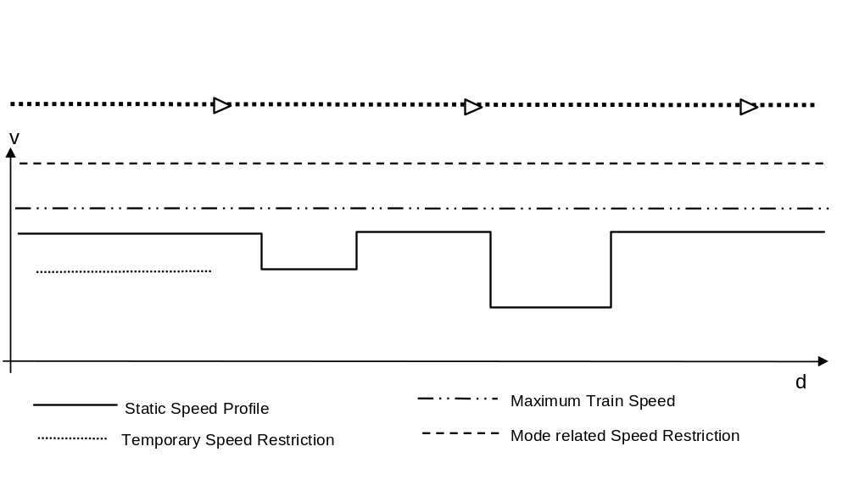Figure 26: Example of Static Speed Restriction categories on a piece of track.

Depending on the type of Static Speed Restriction train length may have to be used to ensure that the full length of the train has passed a Static Speed Restriction discontinuity before a speed increase shall be taken into account.

Compensation for train length shall be handled by the on-board equipment.

Temporary Speed Restrictions shall be valid until the train has passed the Temporary Speed Restriction or until the Temporary Speed Restriction has been revoked by the trackside.

Static Speed Profile (SSP)
FRS references: 4.2.1 - Infrastructure data collection; 4.3.1 –Static train speed profile calculation;

The Static Speed Profile (SSP) is a description of the fixed speed restrictions of a given piece of track. The speed restrictions can be related to e.g. maximum line speed, curves, points, tunnel profiles, bridges.

The Static Speed Profile is based on factors, which are both track and train dependent. The relationship between track and train characteristics determine the individual Static Speed Profile for each train.

It shall be possible for every element (distance between two discontinuities) of a static speed profile to define, if a transition to a higher speed limit than the speed limit specified for this element is permitted before the complete train has left the element.

Static Speed Profile Categories

A maximum of 16 Static Speed Profile Categories shall be defined; one Basic SSP category and 15 specific SSP categories related to the international train categories.

The Basic SSP shall always be given and shall be used for a train if no specific SSPs related to its train categories are given by the trackside.

It shall be possible to give multiple specific SSPs covering the same part of the track.

Specific SSPs related to the international train category "cross wind sensitivity" shall not be used (§5.1.1.2 in SUBSET-108 v100).

The speed profiles corresponding to the specific SSP categories shall be stored trackside and can be selected to be transmitted to the on-board equipment according to the specific train category.

Specific SSP categories not relevant to the current train shall be ignored.

The on-board equipment in a train belonging to several train categories shall use the corresponding specific SSP categories. In this case the most restrictive speed defined for each segment of the track by the specific SSP categories matching the train categories shall be supervised.

Train categories

A maximum of 16 train categories shall be defined to match the SSP categories. One Basic train category and 15 specific train categories.

A train shall belong to at least one train category.

The train categories to which a train belongs shall be a part of its Train Data.

Axle load Speed Profile

It shall be possible to define an Axle load Speed Profile as a non-continuous profile.

For each section with a speed restriction due to axle load, the different speed value(s) and for which minimum axle load this speed value(s) applies shall be specified.

Note: Different speed restrictions depending on the axle load can be applicable to the same distance.

Trains with an axle load higher than or equal to the defined minimum value shall consider the speed restriction given for that value.

Trains with an axle load lower than the minimum axle load given in the profile shall not consider any speed restriction due to axle load.

The initial state for Axle load Speed Profile shall be “no restriction due to axle load”.

Whether a speed increase after the axle load speed restriction shall be delayed with train length, shall be determined by the axle load speed profile information sent to the on-board equipment.

Temporary Speed Restrictions

The temporary speed restriction is defined in order to enable a separate category of track infrastructure speed restriction, which can be used for working areas etc.

All Temporary Speed Restrictions shall be independent of each other. This means that an individual Temporary Speed Restriction shall not affect, nor be affected by, any other individual Temporary Speed Restriction.

Whether a speed increase after the temporary speed restriction shall be delayed with train length, shall be determined by the temporary speed restriction information sent to the on-board equipment.

When two or more temporary speed restrictions overlap, the most restrictive speed of the overlapping temporary speed restrictions shall be used in the area of overlap.

Each Temporary Speed Restriction shall have an identity to make it possible to revoke the Temporary Speed Restriction using its identity. The speed restriction shall be revoked immediately when revocation is received from trackside, without delay for the train length.

It shall be possible to identify whether a Temporary Speed Restriction is possible to revoke or not.

A new Temporary Speed Restriction shall not replace a previously received Temporary Speed Restriction with another identity.

Temporary Speed Restrictions shall only be revoked on request from the trackside.

If the on-board equipment receives a new Temporary Speed Restriction (TSR) with the same identity as an already received TSR, the new Temporary Speed Restriction shall replace the previous one, except when the Temporary Speed Restriction is identified as non revocable in which case this shall be considered as an additional TSR.

In case the train has changed its orientation any Temporary Speed Restriction shall be deleted (operational requirement: will be executed due to the mode change).

If no gradient profile information is available on-board, the gradient data received together with the Temporary Speed Restriction shall be used.

Signalling related speed restrictions

In level 1, it shall be possible to send to the on-board equipment a speed restriction with a value depending on the current state of signalling.

This speed value shall be taken into account by the on-board equipment as soon as it is received on-board, with the exception of a signalling related speed restriction from an in-fill device. In case of in-fill information the speed restriction shall be taken into account from the location reference of the balise group at the next main signal.

The speed restriction shall be valid until a new signalling related speed restriction is received.

If the ERTMS/ETCS on-board equipment switches from level 1 to level 2, the signalling related speed restriction shall remain valid until a L2 MA is accepted by the ERTMS/ETCS on-board equipment

In case of a signal at danger the signalling related speed restriction will be zero speed, i.e. train trip condition.

In case of in-fill information the signalling related speed restriction at zero shall be ignored.

Note: The in-fill information will also include an EOA at the next main signal that will be supervised according to the normal rules.

Mode related speed restrictions

The value of the mode related speed restriction shall be determined by the corresponding national value or the corresponding default values if the national values are not applicable. Exception: For the modes On-sight and Shunting the speed limit can also be given from the trackside. The speed limit given from the trackside prevails the National value and the default value.

Train related speed restriction

It shall be possible to define the maximum train speed related to the actual performance and configuration of the train.

Most Restrictive Speed Profile (MRSP)

The Most Restrictive Speed Profile (MRSP) is a description of the most restrictive speed restrictions the train shall obey on a given piece of track.

The Most Restrictive Speed Profile is the minimum, i.e. most restrictive parts, of all speed restrictions.
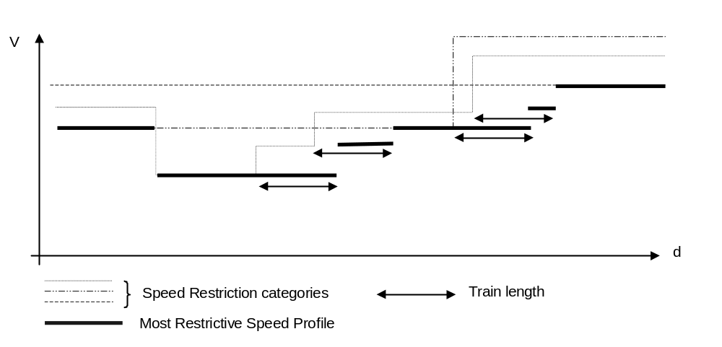
Figure 27: Most Restrictive Speed Profile selection

The Most Restrictive Speed Profile shall be recalculated when any of the elements it is built of is changed.

Gradients

A gradient value shall be positive for an uphill slope.

A gradient value shall be negative for a downhill slope.
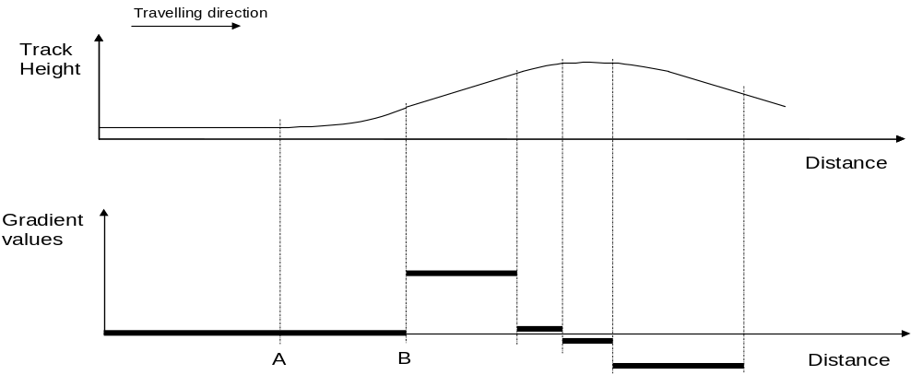
Figure 28: Gradient profile

Between two defined locations, e.g. A and B in the above figure, the trackside shall provide the lowest value of the gradient (taking the sign into account) found between these two locations.

Justification: The figure above symbolises the engineering process to provide the values of gradients. Following the track height, the track must be split in segments giving for each segment a gradient value. This splitting is dependent of the performances required on the line and the different kinds of trains running on this line. The accuracy of the gradient value is determined during the engineering process.

Other Profiles
FRS reference: 4.2.1 – Infrastructure data collection – Remark; 4.6.5 – Inhibit Passenger Brake; 4.8.1 - Control of pantograph and power supply; 4.8.2 - Air conditioning control.

Track Conditions

The Track Condition function is used to inform the driver and/or the train of a condition in front of the train.

A Track Condition shall be given as profile data (e.g. non-stopping area), i.e. start and end of the data is given, or location data (e.g. change of traction power) i.e. start location given, depending on the type of track condition.

The starting point of a profile type track condition shall be evaluated taking into account the max safe front end of the train, the end of the profile taking into account the min safe rear end of the train. Location type data shall be evaluated taking into account the max safe front of the train.

Note: The timing of output data to control train equipment (e.g. pantograph) is application specific.

Exception: The starting point of a Big Metal Mass type track condition shall be evaluated taking into account the max safe antenna position, the end of the profile taking into account the min safe antenna position.

The types of track conditions to be covered by this function are:
- Powerless section, lower pantograph and/or switch off main power switch and/or open circuit breaker (initial state: not powerless section)
- Air tightness (initial state: no request for air tightness)
- Tunnel, stopping not permitted, inhibit passengers emergency brake (initial state: stopping permitted)
- Change of traction power, switch traction on-board, used for train capable of handling several traction powers / frequencies (initial state: no initial state – keep the current setting)
- Bridge, stopping not permitted, inhibit passengers emergency brake (initial state: stopping permitted)

Stopping not permitted (without defined reason), inhibit passenger emergency brake (initial state: stopping permitted)
- Big metal masses, ignore onboard integrity check alarms of balise transmission. (initial state: alarms not ignored)
- Radio hole, stop supervision of the loss of radio link (initial state: loss of radio link supervised)
- Switch off regenerative brake (initial state: regenerative brake on)
- Switch off eddy current brake for service brake (initial state: eddy current brake on for service brake)
- Switch off magnetic shoe brake (initial state: magnetic shoe brake on).

Note: In case of regenerative brake switch off or magnetic shoe brake switch off, the deceleration of the emergency brake might be affected if the effect of these brakes was included in the calculation of the deceleration value.

Note: In case of eddy current brake switch off the deceleration of the service brake might be affected if the effect of these brakes was included in the calculation of the deceleration value.

Intentionally deleted.

The following actions shall be performed at receiving a track condition:
- Indicate on MMI
- Send information with the remaining distance to the train, with the exception of big metal mass track condition and supervision of radio transmission which are handled inside the ERTMS/ETCS on-board equipment.

Note: Whether some information shall be filtered (not shown to the driver or not sent to the train) is outside the scope of ERTMS/ETCS.

Note: The ERTMS/ETCS external train function must be able to handle new track condition of the same type as previously received and covering the same distance.

The train is permitted to run without any track condition information given from the trackside. The initial state shall then be used by the on-board equipment.

Route Suitability
FRS reference: 4.6.11 – Route Suitability protection

Route suitability data defines which values concerning loading gauge, power supply and axle load a train must meet to be allowed to enter the route.

The route suitability data shall be sent as profile data from the trackside when needed.

The on-board equipment shall ensure that only trains that are compatible with the route suitability data are allowed to enter the area of unsuitability.

The information about unsuitability shall be displayed when received to make it possible for the driver to choose a suitable location to stop.

When the train is stationary, the driver shall have the possibility to override the route suitability function. Each type of route suitability data shall be handled separately.

Justification: The reason for this is that the driver may remove the reason for the unsuitability, i.e. move the out-of-gauge load, lower pantograph and switch on diesel engine.

In case new route suitability data is received by the on-board equipment the driver must repeat the override of route suitability when applicable.

If the driver has overridden the route suitability function the train is permitted to continue according to the given movement authority and track description. The action shall be recorded.

If the driver does not override the route suitability function the train shall be stopped in rear of the first location where incompatibility occurs.

Train Data (concerning route suitability) shall be sent to the RBC.

Note: This allows for route suitability supervision to be used in systems external to the ERTMS/ETCS system.

The train is permitted to run without any route suitability data given from the track. No default values shall be used or supervised by the on-board equipment, i.e. the initial state is that no restrictions related to route suitability exists.

Text Transmission
FRS reference: 4.8.8 - Plain Text Transmission

General Rules

It shall be possible to transmit information to be displayed to the driver from the trackside to the on-board equipment in the form of text messages.

Text messages shall always be supplemented by conditions on when and where they are to be displayed, and whether any confirmation is requested from the driver. These parameters shall be transmitted individually for each message.

Text messages and the supplementary information shall always be transmitted in one message.

Text messages can contain the text to be displayed in plain text or a number selecting a fixed message.

Note: In case of plain text messages the trackside selects the language in which the message is displayed.

If more messages of the same class are to be displayed at the same time than there is display space, the newest message shall take precedence over older messages. This shall however be indicated to the driver. It shall also be possible to select the different hidden messages for display and confirmation.

Hidden messages shall remain stored and shall reappear once newer messages are deleted.

Messages to be confirmed by the driver shall not be hidden behind newer messages of the same class which require no driver confirmation.

If a message to be confirmed is hidden behind another message to be confirmed it shall reappear after the first confirmation.

The following data shall be included in a text message:
- Class of message
- Plain text message or fixed message number
- Conditions for start of indication
- Conditions for end of indication
- Optional driver confirmation

The appearance of a message shall depend on the class.

Text Message Classes

Text messages shall be classified according to the following scheme:
Class | Characteristics/Appearance | Use
Auxiliary Information | Displayed and deleted when specified conditions are met. May be hidden behind a message of another class. | Auxiliary operational information (e.g. station announcement etc.)
Important Information | Displayed and deleted when specified conditions are met. Shall never be hidden behind a message of another class. | Important operational information (e.g. information about workers on the line etc.).

Fixed text messages

Fixed text messages shall be stored on-board.

It shall be possible for the driver to select the language in which fixed messages shall be displayed.

Each message shall be stored at least in English and optionally in any other languages.

If the driver selects a language, for which no messages are stored the English message shall be displayed as default.

If the on-board receives a fixed text message for which no text is stored onboard the text “unknown text received” shall be shown to the driver.

Conditions for Start/End of Indication

It shall be possible to specify individual conditions for start/end of indication.

The following events can be used as start / end conditions:

Location

Time (for end condition only)
- Driver acknowledgement (for end condition only)
- Mode (display when / as long as in this mode)
- Level (display when / as long as in this level)

It shall be possible to define whether the service brake command shall be given if the driver does not acknowledge before the end conditions are reached. The message shall remain displayed in this case until the driver acknowledges it, after which the brake command shall be revoked.

It shall be possible to define whether one or all start/end conditions has to be fulfilled to start/stop displaying the text.

Mode profile
FRS reference: 4.1.3 – Shunting; 4.2.3 – Supervision of driving into a section of track which is occupied; 4.5.2 – Passing a stop signal with restricted Movement Authority; 4.9.7 –Shunting in an RBC area

The Mode Profile can request On Sight mode and Shunting mode.

For OS mode the mode profile shall define the entry and the length of the On Sight area. For SH mode only the entry of the shunting area shall be defined in the mode profile.

On the reception of a new MA without Mode Profile the on-board equipment shall delete the current Mode Profile.

In case the mode profile information for shunting is overwritten by a new shunting profile, before the on-board equipment switches to SH mode, a previous list of identifiers of balise groups shall be deleted or replaced by a new list of balise groups.

The beginning of the Mode Profile relates to the max safe front end of the train.

The end of the mode profile relates to the min safe front end of the train.

Dynamic Speed Monitoring

Introduction

The speed monitoring is the supervision of the speed of the train versus its position, in order to make the train to respect the Most Restrictive Speed Profile and Limit Of Authority/End Of Authority.

Note: The ERTMS/ETCS on-board equipment issues brake commands and revokes them, it may also receive status information if the brakes are applied or released. However, it cannot be made responsible if brake control circuits outside the ERTMS/ETCS equipment fail. Also the way the brakes are released by the driver after a revocation of a brake command is an implementation issue.

The speed monitoring comprises

The ceiling speed monitoring supervising constant speed curves determined on basis of the current value of the Most Restrictive Speed Profile.

The target speed monitoring supervising the braking to a lower target speed , or to the EOA/LOA.

The release speed monitoring.

The train trip function on passing an EOA/LOA

General Requirements
FRS reference: 4.3.5.2 – Indication of actual speed, 4.3.6.4 – Target speed indication

The train speed indicated on the MMI shall be identical to the speed used for the speed monitoring.

The indicated target (the target speed at a target distance) shall refer to the next relevant target according to the information available to the ERTMS/ETCS on-board equipment.

Input for the speed monitoring
FRS reference: 4.1.2 - Train and driver Data Entry; 4.3.2 - Dynamic train speed profile calculation

Traction / braking models

The traction and braking models give a description of the behaviour of the train after a service brake or an emergency brake has been initiated.

The parameters for these models are specific for each train and the corresponding data is part of the Train Data.

These models shall be used for the specification of the train behaviour. They may consider the train characteristics in a simplified way but this shall always be done in a safe way.

The traction model describes the time delay between ordering traction cut off and the actual cut off of the traction.
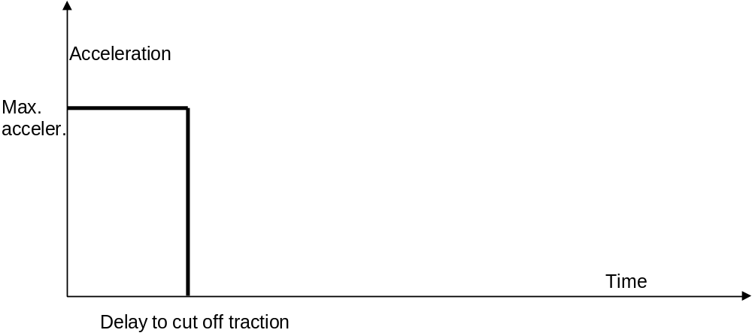
Figure 29: Traction model

The braking models (service brake model and emergency brake model) describe:
- the time delay between ordering brake application and reaching full brake effort.
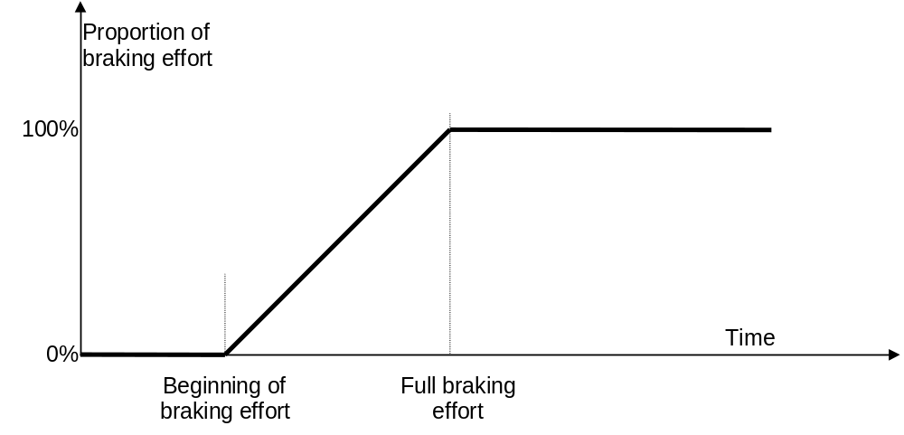
Figure 30: Braking model (progressive application of brakes)
- the braking capacity of the train depends of the train speed; the corresponding function (deceleration = F(speed)) is defined as a succession of sections with a constant deceleration.
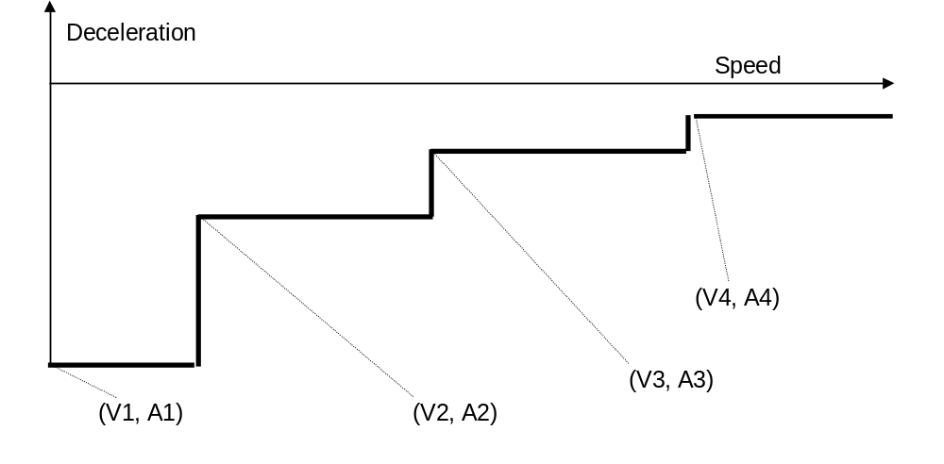
Figure 31: Braking model (speed dependency of the braking capacity)

Note: There is no correlation between the traction and the braking models, i. e. the time to cut off the traction can be higher than the time to apply 100% of the brakes.

Track adhesion
FRS references: chapters 4.2.1 - Infrastructure data collection, 4.3.2 - Dynamic train speed profile calculation

The track adhesion affects the braking models by multiplying the track adhesion factor to the braking model:
deceleration = F(speed) * track adhesion factor.

The track adhesion shall affect both emergency and service braking models.

Most restrictive speed profile

The speed monitoring with respect to the most restrictive speed profile shall take into account the minimum of the static speed restrictions applicable to the train and the length of the train, where necessary (see section 3.11.9).

Gradient profile

The speed monitoring shall take into account the acceleration due to the gradient profile.

The acceleration due to the gradient profile underneath the train shall be determined in a safe way.

MA data

The Limit of Authority (LOA), End of Authority (EOA), and Supervised Location (SvL) shall be taken into account.

Train Movement

The speed monitoring shall be based on estimated (i.e. measured) value of the train speed.

Deleted.

The maximum acceleration of the train shall be taken into account where required for safety.

The train position shall be taken into account as detailed in the coming sections.

Supervision Limits
FRS reference: 4.3.6 – Indication of MA and Speed Limits, 4.3.7 Supervision of MA and Speed Limits

Note: The supervision limits described in the SRS are only defined as far as required for interoperability. The algorithm for their calculation is an implementation matter. This chapter specifies general rules, the following ones special conditions.

The speed limits described in this chapter shall be calculated for the Ceiling Speed and Target Speed monitoring, also a subset for the Release Speed monitoring. By comparing the train speed and location of the train to the various supervision limits, the system shall generate indications to the driver and braking actions.

The supervision limits shall take into account the input data specified in the previous chapter. This may be done in a simplified way as long as the safety of the train is ensured.

The Permitted Speed limit (abbreviated as P)

The permitted speed is the speed the driver is requested to follow and shall be indicated to the driver.

The Warning limit (abbreviated as W)

If the train speed exceeds the warning limit, a warning shall be triggered, allowing the driver to avoid brake intervention.

After a warning has been triggered it shall remain active until the train speed is equal to or below the permitted speed.

The Service Brake Intervention limit (abbreviated as SBI)

The service brake shall be used as First line of system intervention unless
- No interface to the service brake is available on a train
- The use of the service brake is inhibited for Target Speed Monitoring by means of a National Value.

The Service Brake is considered not safe, therefore it shall be backed up, as Second line of intervention, by the emergency brake. This is ensured by means of the Emergency Brake Intervention limit (see below).

If the train speed exceeds the Service Brake Intervention limit, the system shall command the service brake to be applied.

After the service brake has been triggered, the brake command shall be revoked when the train speed is equal to or below the Permitted Speed limit

The service brake intervention shall be indicated on the MMI.

The Emergency Brake Intervention limit (abbreviated as EBI)

The emergency brake shall be used as First line of intervention in the following cases:
- Release Speed supervision
- Train trip
- Service brake is not available (refer to 3.13.4.6.1)

If the train speed exceeds the Emergency Brake Intervention limit, the system shall command the emergency brake to be applied.

If the emergency brake command was triggered, the emergency brake command shall be released as follows:

If the emergency brake is used as second line of intervention: When the train speed is equal to or below the Permitted Speed limit or at standstill, depending on a National Value.

If the emergency brake is used as first line of intervention:

If no service brake is available: when the train speed is equal to or below the Permitted Speed limit.

If triggered by Release Speed supervision: at standstill.

The emergency brake intervention shall be indicated on the MMI.

The Indication limit

On the approach to a target speed monitoring section a indication shall be given to the driver early enough to allow him to start braking before the Permitted Speed begins to decrease.

Special Requirements for the Ceiling Speed Monitoring Section (CS)
FRS reference: 4.3.7 - Supervision of MA and Speed Limits

A Ceiling Speed Monitoring (CS) section is a section where the permitted speed is constant, defined by the current value of the most restrictive speed profile.

The following requirements have to be considered as addition to the general requirements specified in section 3.13.4.

The Permitted Speed limit (P) shall correspond to the value of the most restrictive speed profile (refer to section 3.11.9)

Refer to the figure below: The Emergency Brake Intervention limit (EBI) shall be determined in relation to the permitted speed limit using the following algorithm:
DV_EBI = Min ( DV_EBImin + C_EBI * V_Permitted, DV_EBImax )

Where C_EBI = (DV_EBImax – DV_EBImin)/V_EBImax
The parameters DV_EBImin, C_EBI, DV_EBImax shall be predefined values, see Appendix A3.1.

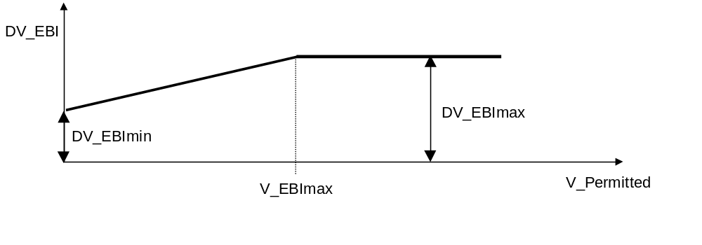
Figure 32: Definition of the EBI limit in relation to the Permitted Speed (P)

If the service brake is available the service brake intervention limit shall be calculated such that, in reference to the expected brake performance, the emergency brake intervention limit is not reached.

Special Requirements for the Target Speed Monitoring
FRS references: 4.3.2 - Dynamic train speed profile calculation, 4.3.7 - Supervision of movement authorities and speed limits, 4.3.7 - Supervision of movement authorities and speed limits

General

The following requirements have to be considered as addition to the general requirements specified in section 3.13.4.

Note: No special requirements are necessary for the Permitted Speed limit and Warning limit for target speed monitoring.

If the service brake is available for target speed monitoring, the Service Brake Intervention (SBI) limit shall comply, in reference to the expected brake performance, with the most restrictive of the following two requirements:
- The SBI limit shall be calculated such that the SBD limit (reflecting the expected deceleration with the service brake fully applied) is not exceeded at the given target location and for the given target speed.
- It shall avoid that the Emergency Brake Intervention limit is reached.

The EBI limit shall be calculated such that the EBD limit (reflecting the expected deceleration with the emergency brake fully applied) is not exceeded at the given target location and for the given target speed, unless the expected brake performance is not available.

Two types of target speed monitoring can be defined, depending on the type of target:
- When the train is braking to a target speed.
- When the train is braking to an EOA section.

Special Requirements for the Braking to a Target Speed (BTS)
FRS reference: - none

Note: A Braking to a Target (BTS) section is a section where the permitted speed curve decreases from the current value to a lower one.

The target location shall be defined by

A Limit of Authority (LOA, Speed limit at LOA).

The beginning of a speed restriction.

Note: An LOA is for this speed monitoring considered in the same way the beginning of a speed restriction.

The limit representing the speed decrease with the emergency brake fully applied (EBD limit) shall be calculated such that it intersects with the EBI curve in the CS section at the change of SSP (the target location).
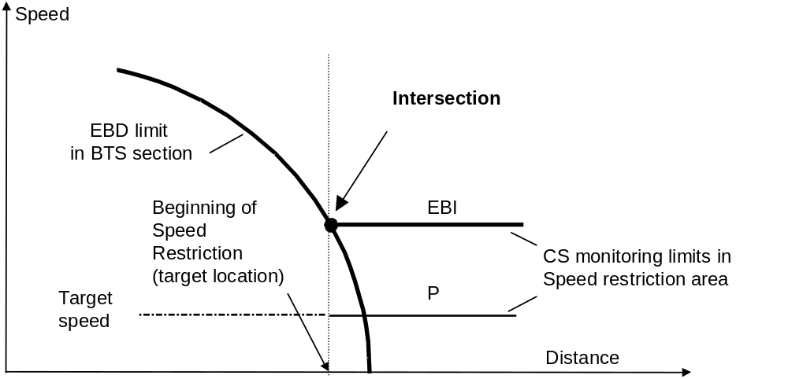
Figure 33: Calculation of the EBD curve with regards to the target location

The supervision with regards to the target location shall refer to the train front using the max safe value.

Special Requirements for the EOA section
FRS reference: - none

The EOA section is a section where the permitted speed curve decreases from the current value to zero speed at the EOA.

Note: For the end of the section the Release Speed supervision may apply (see section 3.13.7).

Case 1: Service brake is first line of intervention

The supervision limits of the Braking to the EOA section shall be calculated such that
- The EBD curve reaches the zero speed at the Supervised Location (SvL).
- The SBD, W and P curve reaches the zero speed at the End Of Authority (EOA).

On calculating the emergency brake limits, the distance to the SvL shall be determined using the maximum safe front end.

On calculating the service brake, W and P limits, related to the EOA, the distance to the EOA shall take into account the minimum of
- The distance to the EOA taking into account the estimated position of the train front.
- The distance to the SvL taking into account the maximum safe front end position.

Justification: Using the estimated value increases the operational flexibility (i.e. supervision on the approach to the EOA is less restrictive).

Case 2: Emergency brake is first line of intervention

All supervision limits (emergency brake, W and P limits) shall refer to the EOA.

On calculating the limits, the distance to the EOA shall take into account the minimum of
- The distance to the EOA taking into account the estimated position of the train front.
- The distance to the SvL taking into account the maximum safe front end position.

Release Speed (RS) Monitoring
FRS reference: 4.3.3 - Release speed calculation

Introduction

The Release Speed (RS) monitoring applies to the section near the EOA, where the speed is monitored against a constant value, the Release Speed.

Note: In the RS section the protection of the EOA is only ensured by the train trip monitoring function (see next section).

Determination of the release speed

The Release Speed can be determined trackside or calculated on board. It shall be possible
- To receive a value from the trackside, as part of the MA.
or
- To calculate the value on-board.
or
- To use a national value.

The MA shall identify the variant to be used. If no variant is specified, no release speed shall be supervised.

If the protection of the Supervised Location must be ensured,
- The Release Speed shall be calculated on-board, taking into account as stopping distance the distance between the SvL and the max safe front end when the train is tripped (i.e. when the min safe front end passes the EOA (see below)).
or
- The trackside value shall be low enough to ensure that any type of train can be stopped in rear of the SvL, if tripped.

Release Speed Monitoring

If the train speed exceeds the Release Speed a command to apply the emergency brake shall be triggered.

The transition to the release speed monitoring shall be executed automatically when the Release Speed value is equal to the first line of intervention limit (service brake or emergency brake) of the target speed supervision.

The EBI and the SBI (when applicable) limits for the target speed monitoring shall not be supervised any more.

A warning limit (W) shall be provided triggering a warning, which remains active as long as the train speed exceeds it. The warning limit shall be lower than the Release Speed. The transition shall be executed when the warning limit of the target speed monitoring is equal to the warning limit of the Release Speed monitoring.

It shall be clearly indicated that the Release Speed is supervised and the value of the Release Speed.

The Permitted Speed (P) limit indication of the target speed monitoring shall be continued, decreasing to zero value.

The following figure illustrates this, when the service brake is applicable:
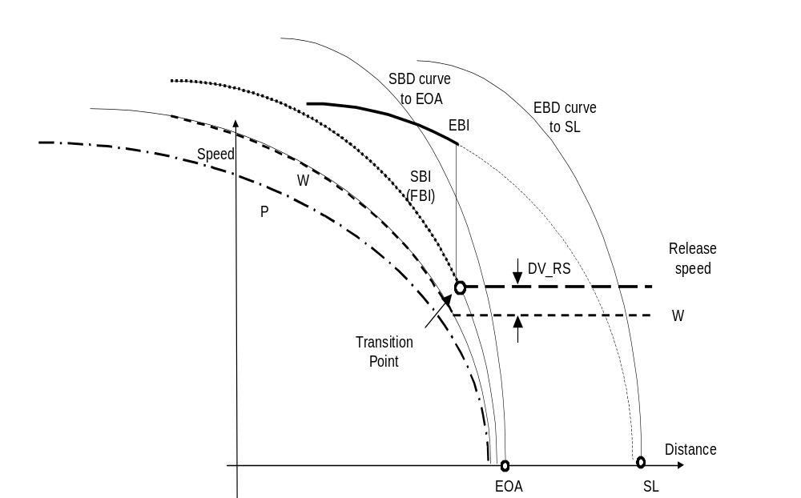
Figure 34: Release Speed Monitoring

Train trip monitoring on passing the EOA/LOA
FRS reference: 4.6.12 - Train trip

Level 2/3: Train trip shall be initiated if the on-board equipment detects that the minimum safe front end has passed the EOA/LOA.

Level 1 : Train Trip shall be initiated if the on-board equipment detects that the minimum safe antenna position (calculated by subtracting distance between active Eurobalise antenna and the front end of the train from the min safe front end position) has passed the EOA/LOA and no new data has been received up to this point.

Refer to section 3.14.1

Note: The train trip can be overridden (refer to chapter 5 Override).

Brake Command Handling and Protection against Undesirable Train Movement

Brake Command Handling

Note: Whenever the type of brake used is not specified explicitly in the text, it shall be interpreted as not being important for technical interoperability and being a property of the specific implementation.

In case only the application of (the non-vital) service brake has been commanded and the service brake fails to be applied, the emergency brake command shall be given.

If the emergency brake command was triggered due to a trip condition (see chapter 4) the emergency brake command shall be released at standstill and after driver acknowledgement of the trip condition.

If the supervision of the dynamic speed results in an service brake command, the service brake command shall be released when the train speed is equal to or below the Permitted Speed limit.

If the brake command was triggered due to roll away protection, reverse movement protection or standstill supervision the brake command shall be released at standstill and after driver acknowledgement.

If the brake command was triggered due to linking error, balise group message inconsistency or RAMS related supervision error, the brake command shall be released at standstill.

If the brake command was triggered due to supervision of the radio link (T_NVCONTACT) the brake command shall be released at standstill or if a new message has been received from the RBC.

An indication shall be given to the driver to indicate when the brakes can be released and when an acknowledgement is requested.

Roll Away Protection
FRS reference: 4.3.9 – Roll away / reverse movement detection

Note: This protection is only applicable if the required information can be obtained from the direction controller.

The Roll Away Protection (RAP) shall prevent the train from moving in a direction, which conflicts with the current position of the direction controller in the active desk.

If the controller is in neutral position, the RAP shall prevent forward and reverse movements of the train.

When the system recognises a movement exceeding the national value for the allowed roll away distance the brakes shall be triggered.

Refer to section 3.14.1.

An indication shall be given to the driver showing when the RAP is commanding the brakes.

After revocation of the brake command the RAP will be re-initialised using the current position of the train as the new reference location.

Reverse Movement Protection

The Reverse Movement Protection (RMP) shall prevent the train from moving in the opposite direction to the permitted one. The permitted movement direction of a train shall be the one of the currently valid MA, if available on-board. See chapter 4 concerning permitted direction in case of SR mode.

When a reverse movement is detected, the brake command shall be triggered after a distance specified by the national value.

Refer to section 3.14.1.

An indication shall be given to the driver showing when the RMP is commanding the brakes.

After revocation of the brake command the RMP will be reinitialised using the current position of the train as the new reference location.

Information received from balises during reverse movement shall be rejected.

Standstill supervision

This function shall prevent the train from moving.

When a movement is detected, the brake command shall be triggered after a distance specified by the national value.

Refer to section 3.14.1.

After revocation of the brake command the standstill supervision will be re-initialised.

Special functions

RBC/RBC Handover
FRS reference: 11.1.1 – Handover when passing from one RBC area to another

Introduction

Trains with one or two radio(s) shall be able to pass from one RBC area to another automatically (without driver action).

Since an RBC is unable to know whether the on-board is able to manage one or two ERTMS/ETCS session(s) at once, the following principles are applicable for both cases. Thereby, the RBCs will have the same behaviour in both cases.

An RBC/RBC handover performed by a train with one ERTMS/ETCS session available may result in performance penalties since it will not be able to “prepare” (session establishment, version determination, …) the expected supervision by the Accepting RBC until the on-board disconnects from the Handing Over RBC.

In level 3, trains following the one with one ERTMS/ETCS session available will always suffer performance penalties since no more position reports will be issued from the disconnection from the Handing Over RBC until the connection to the Accepting RBC.

Handing Over RBC

When the Handing Over RBC detects that a route is set for a train to enter another RBC area, it shall send:
- To the on-board equipment an order to switch to the Accepting RBC (including identifier and telephone number of the Accepting RBC) at a given location (corresponding to the border).
- To the Accepting RBC the following information:
- The identification of the train that will enter the Accepting RBC area;
- The border location that will be passed by the train when entering the Accepting RBC area.
- Optionally, Train Data

The Handing Over RBC shall not send information to an on-board equipment concerning the route in advance of the border without receiving the corresponding information from the Accepting RBC.

It shall be possible for the Handing Over RBC to request route related information from the Accepting RBC.

Note: Route related information is :
- Movement authorities
- Linking
- International static speed profiles
- Axle Load Speed profiles
- Gradients
- Temporary speed restrictions
- Mode profiles
- Emergency stops
- Track Conditions
- Level Transition orders
- List of balises in SR authority
- Route Suitability Data
- National Values

Note: The amount of information to be sent between the RBCs is depending on the implementation trackside.

Note: Route related information received from the Accepting RBC will be processed by the Handing Over RBC if possible.

Deleted.

When the Handing Over RBC receives a position report and detects that the maximum safe front end has passed the given location (the border), it shall forward this information to the Accepting RBC.

Note: This information might be needed to inform the signalman of the Accepting RBC that the train has entered the Accepting RBC area.

When the Handing Over RBC receives a position report and detects that the minimum safe rear end of the train has crossed the border, it shall send a disconnection order to the on-board equipment.

When the Accepting RBC informs the Handing Over RBC that it has taken over the responsibility, the latter shall stop sending route related information to the on-board equipment.

When the Handing Over RBC detects that the transition to the Accepting RBC has to be cancelled, it shall send this cancellation information to the Accepting RBC (including the train identification).

Note: For instance, the cancellation procedure can be triggered by:
- Change to a route which does no more include the border;
- The sending of an “end of mission” information from the on-board equipment.

On-board equipment

When receiving an order to switch to another RBC at a given location, the on-board equipment shall:
- Establish the ERTMS/ETCS session with the Accepting RBC;
- Send a position report to the Handing Over RBC when the maximum safe front end of the train passes the given location;
- Send a position report to the Handing Over RBC when the minimum safe rear end of the train passes the given location;

It is up to the on-board equipment to manage the establishment of one ERTMS/ETCS session and the release of the other one:
- If it is able to handle two ERTMS/ETCS sessions at the same time, the radio session with the Accepting RBC shall be established as soon as it receives the RBC transition order.
- If it is able to handle one ERTMS/ETCS session only at a given time, it shall wait until the session with the Handing over RBC is terminated and then establish the session with the Accepting RBC.

As soon as the on-board equipment has established the session with the Accepting RBC, it shall send its Train Data unless it is in sleeping mode.

When the on-board equipment is connected to both RBCs, it shall send its position reports to both of them with the use of the position report parameters valid for the Handing Over RBC.

When the on-board sends a position report directly to the Accepting RBC with its maximum safe front end having passed the border, it shall use information received from the Accepting RBC and only a disconnection order shall be accepted from the Handing Over RBC.

Note: This requirement implies that the connection to the Accepting RBC and that the determination of the version have been achieved and that the on-board is able to handle two ERTMS/ETCS sessions at the same time.

In case two ERTMS/ETCS sessions are opened, if information is received from the Accepting RBC before a position report is sent to the Accepting RBC with the maximum safe front end having passed the border, this information shall be stored on-board.
Exception: The acknowledgement of Train Data shall be immediately accepted by the on-board equipment.

Note: for the exhaustive list of accepted/rejected information, please refer to Chapter 4 Use of received information.

Intentionally deleted.

Accepting RBC

The Accepting RBC shall keep route related information sent to the Handing Over RBC updated. In particular, this possibly includes emergency messages, temporary speed restrictions.

As soon as the Accepting RBC receives from the on-board equipment a position report and detects that the maximum safe front end of the train has passed the border, it shall inform the Handing Over RBC that it has taken over the responsibility.

When the Accepting RBC receives Train Data from both the on-board equipment and the Handing over RBC Train Data provided by the on-board equipment shall take precedence.

If the Accepting RBC receives a cancellation information from the Handing Over RBC, it shall send an order to terminate the communication session to the corresponding on-board equipment (if already established).

Handling of Trains with Non Leading Engines

It shall be possible to operate a train using more than one engine, each engine being under the control of a driver.

Only the leading engine shall be responsible for the train movement supervision functions.

Splitting/joining

ERTMS/ETCS shall allow Splitting and Joining using the normal supervision functions available (e.g. On-sight, Shunting).

Splitting only refers to the case that the two resulting trains contain at least one ERTMS/ETCS on-board equipment each.

Note: This must be ensured by operational procedures.

ERTMS/ETCS is not responsible for providing information that a Splitting/Joining operation has been correctly completed (technical aspect and/or operational aspect).

Justification: ERTMS/ETCS is not able to provide this information. Splitting and Joining shall require the fulfilment of operating rules ensuring that a Splitting/Joining operation has been correctly completed (e.g. physical disconnection).

Reversing of movement direction

It shall be possible to send in advance to an on-board equipment information about areas, where initiation of reversing of movement direction is possible, i.e. change the direction of train movement without changing the train orientation.

Together with start and end of reversing area, the following information shall be sent:
- Maximum distance to run in the direction opposite to the orientation of the reversing area, the reference location being the end location of the area where reversing of movement is permitted.
- Maximum speed allowed during reverse movement.

New distance to run and maximum speed information given from the trackside shall replace the one already available on-board.

Update of distance to run in reverse movement shall also refer to the end location of the area where reversing of movement is permitted. (See 4.4.18.1.3 b).

While at standstill with the front end of the train inside the indicated area, it shall be possible for the driver to reverse the direction of movement.

The on-board equipment shall allow movement in the direction opposite to the train orientation, supervising it according to distance and speed received, without the need of a confirmation from the RBC.

No level transitions, mode profile or RBC area change shall be implemented in an area where reversing of movement is permitted.

When at standstill the on-board equipment shall inform the driver if the reversing of movement is permitted.

If the maximum distance to run in the opposite direction is passed the brake command shall be triggered.

Track ahead free

In a level 2/3 area, the ERTMS/ETCS on-board equipment shall be able to handle a track ahead free request given by the RBC.

The track ahead free request from the RBC shall indicate to the on-board
- at which train location the ERTMS/ETCS on-board equipment shall begin to display the request to the driver.
- at which train location the ERTMS/ETCS on-board equipment shall stop to display the request to the driver (in case the driver did not acknowledge).

The driver shall have the possibility to acknowledge the track ahead free request (meaning the driver confirms that the track between the head of the train and the next signal or board marking signal position is free).

When the driver acknowledges, the ERTMS/ETCS on-board equipment shall stop displaying the request, and shall inform the RBC that the track ahead is free.

There shall be no restrictive consequence by the on-board system if the driver does not acknowledge.

Deleted.

On-board functionality for level STM

The ERTMS/ETCS on-board shall support driving on national infrastructure using an STM configuration.

It shall be possible to perform supervision of MA, most restrictive speed profile and gradient based on information received from the national trackside equipment via the relevant STM.

Note: MA, most restrictive speed profile and gradient supplied together by the STM are called STM profile data.

It shall be possible for the ERTMS/ETCS on-board to give access to various resources MMI, odometer, Juridical Recorder and train interface (e.g. brakes) to the STM.

A brake command, given by the ERTMS/ETCS on-board or the active STM respectively, shall be revoked by the same unit.

Tolerance of Big Metal Mass

Big metal object in the track, exceeding the limits for big metal masses as defined in Subset-036, section 6.5.2 “Metal Masses in the Track” may trigger an alarm reporting a malfunction for the onboard balise transmission function.

In Levels 0/STM, the alarms which may be triggered by metal masses shall be ignored for a defined distance (see A3.1). If the alarm persists for a longer distance the ERTMS/ETCS on-board equipment shall trigger a safety reaction.

Justification: Ignoring the alarm for a defined distance eliminates the need to equip all excessive big metal masses with track condition “Big Metal Mass” outside ETCS fitted areas.

Data Consistency

Criteria of consistency

The on-board shall not consider a message transmitted from the trackside if any of the following criteria is not fulfilled.
- Correctness of the received message: the whole message shall be complete and respect the ETCS language; variables shall not have invalid values
- The message shall be received in due time.
- The message shall be received at the right expected location.
as stated below.

Note: a value of a variable is invalid, if it cannot be processed by the receiver, e.g., spare values, identity of LRBG indicated in a radio message not known on-board, etc

Balises

Definitions

The information that is sent from a balise is called a balise telegram.

The whole set of information (balise telegram or telegrams) coming from a balise group is called a balise group message.

Note: In case of a balise group containing a single balise, telegram and message coincide.

A balise within a balise group shall be regarded as missed if
- No balise is found within the maximum distance between balises from the previous balise in the group.
or
- A following balise within the group has been passed.

General

If the on-board is not able to recognise whether a balise group is linked or unlinked (if none of the balises in the balise group can be read correctly), it shall consider it as unlinked.

Deleted

Linking Consistency

If linking information is used the on-board shall reject the message from the expected group and react according to the linking reaction information in the following cases:
- If the location reference of the linked balise group is found in rear of the expectation window
- If the location reference of the expected group is not found inside the expectation window (i.e. found beyond the expectation window or not found at all).

The on-board shall reject the message from the expected group and trip the train if the balise group is passed in the unexpected direction.

If the location reference balise of the group is duplicated and the on-board is only able to correctly evaluate the duplicating one, the duplicating one shall be used as location reference instead.

If the balise duplicating the location reference balise is used as location reference for the group, and is found within the expectation window, no linking reaction shall be applied.

Balise Group Message Consistency
FRS reference: - none

If linking information is used, the on-board shall reject the message from a linked balise group found in the expected location and react according to the linking reaction in the following cases :
- A balise is missed inside the group.
- A balise is detected but no telegram is decoded (e.g. wrong CRC,...).
- Variables in the balise group message have invalid values.
- Message counters do not match (see 3.16.2.4.7)

Concerning a) and b) above, no linking reaction shall be applied if the balise not found, or not decoded, is duplicated within the balise group and the duplicating one is correctly read.

If linking information is used, the on-board shall reject the message from a balise group marked as linked but not included in the linking information. No reaction shall be applied, even if errors in the reading of the balise group occur.

If no linking information is used, the on-board shall reject the message from a balise group marked as linked and command the application of the service brake in the following cases:
- A balise is missed inside the group.
- A balise is detected, but no telegram is decoded (e.g. wrong CRC).
- Variables in the balise group message have invalid values.
- Message counters do not match (see 3.16.2.4.7)

Concerning a) and b) of clause 3.16.2.4.4, no message consistency error reaction shall be applied if the balise not found, or not decoded, is duplicated within the balise group, the duplicating one is correctly read and the orientation of the balise group can still be evaluated.

Concerning clause 3.16.2.4.4, if the service brake is applied, the current MA and track description, if available on-board, shall be shortened to the current position when the train has reached standstill. In level 2/3 applications the RBC shall be informed.

Concerning clause 3.16.2.4.4, if the service brake is applied, the driver shall be informed that this is due to a balise group message consistency problem.

A message counter shall be attached to each balise telegram indicating which balise group message the telegram fits to.

Instead of a message counter corresponding to a given balise group message, it shall be possible to identify a telegram as always fitting all possible messages of the group.

It shall also be possible to identify a telegram as never fitting any message of the group.

Comparing message counters of the received telegrams of a balise group message, excluding the ones complying with 3.16.2.4.6, if their values are not all identical, or at least one of them complies with 3.16.2.4.6.1, this shall be considered as a message consistency error. The balise group can, however, be used for location information.

It shall be possible to indicate failures in the system underlying the balise/loop/RIU (e.g. the Lineside Electronic Unit , LEU) by sending a balise telegram, a loop message or a RIU message including the information "default balise/loop/RIU information".

If one (and only one) out of a pair of duplicated balise telegrams received by the on-board includes the information “default balise information”, the on-board shall ignore any other information included in this telegram and shall consider information from the telegram not containing “default balise information".

When duplicated balises are both found and decoded correctly, and both, or none of them, contain "default balise information", the ERTMS/ETCS on-board equipment shall compose the message using the telegram from the last received balise out of the pair.

If a message has been received containing the information "default balise information", the driver shall be informed (see Table 4.7.2: error messages).

Unlinked Balise Group Message Consistency

An on-board equipment shall reject the message received from a balise group marked as unlinked and command the service brake to be applied in the following cases:
- A balise is missed inside the unlinked balise group.
- A balise is detected, but no telegram is decoded (e.g. wrong CRC).
- Variables in the balise group message have invalid values.
- Message counters do not match (see 3.16.2.4.7)

Concerning a) and b) of clause 3.16.2.5.1, no message consistency error reaction shall be applied if the balise not found, or not decoded, is duplicated within the balise group, the duplicating one is correctly read and the orientation of the balise group can still be evaluated.

Concerning clause 3.16.2.5.1, if the service brake is applied, the current MA and track description, if available on-board, shall be shortened to the current position when the train has reached standstill.
In level 2/3 applications the RBC shall be informed.

Concerning clause 3.16.2.5.1, if the service brake is applied, the driver shall be informed that this is due to a balise group message consistency problem.

Linking Reactions

When the linking reaction leads to train trip or a service brake application, the driver shall be informed that the intervention is due to data consistency problem with the expected balise group.

If the service brake is initiated due to the linking reaction, the current MA, track description and linking information shall be shortened to the current position when the train has reached standstill.
In level 2/3 applications the RBC shall be informed.

RAMS related supervision functions

If 2 consecutive linked balise groups announced by linking are not detected and the end of the expectation window of the second balise group has been passed, the ERTMS/ETCS on-board shall command service brake. At standstill, the current MA and track description, if available on-board, shall be shortened to the current position. The driver shall be informed (reason: rule ETCS_OB03 in Subset 091).

If re-positioning is announced and the repositioning balise group found, and no further re-positioning is announced, but the next balise group contains again re-positioning information, then the ERTMS/ETCS on-board shall command the service brake. At standstill, the current MA and track description, if available on-board, shall be shortened to the current position. The driver shall be informed (reason: rule ETCS_OB04 in Subset 091).

Radio

General issues

The on-board shall reject a message received by radio and inform the trackside in the following cases:
- The message can not be decoded.
- Variables in the messages have in-valid values (e.g. identity of LRBG not known on-board).

Emergency messages shall be transmitted either as high priority data or as normal priority data.

Other messages shall be sent as normal priority data.

Messages shall only be accepted when received with the data priority for which they are specified.

The following chapters define data consistency principles and corresponding checks for data transmitted as normal priority data.
For high priority data, the checks shall not apply.

Time stamping
FRS reference: - none

The trackside shall always transmit its information with reference to the train time.

To time-stamp its messages, the trackside shall make a safe estimation of the on-board time, based on the time-stamp of the received messages and the internal processing times.
The estimation shall be made in such a way that the on-board time estimated by the trackside shall not be in advance of the real on-board time.

Wrap around of the onboard timer can occur during a radio session and shall have no impact on system behaviour.

Supervision of Sequence
FRS reference: - none

The trackside shall time-stamp a message with a value corresponding to the time of sending.

There shall always be a time stamp increment between consecutive messages.

If the time stamp of the last received message is lower than or equal to the former one its content shall not be used.

If, at the initiation of the communication session, the time stamp is set to unknown the message shall be accepted.
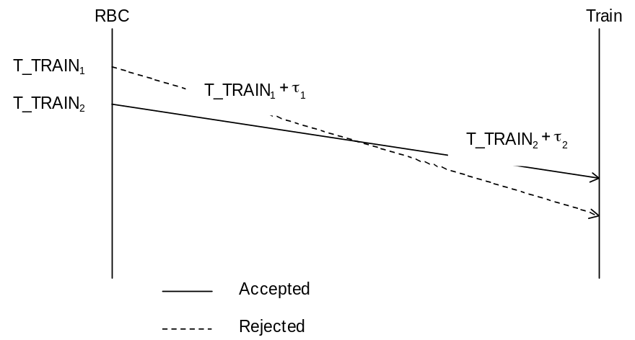
Figure 35: Supervision of sequence

Supervision of the Radio link
FRS reference: - none

When the difference between the time stamp of the latest valid received message and the current on-board time is greater than the T_NVCONTACT parameter (national value), the on-board shall apply the reaction as defined in the next section.
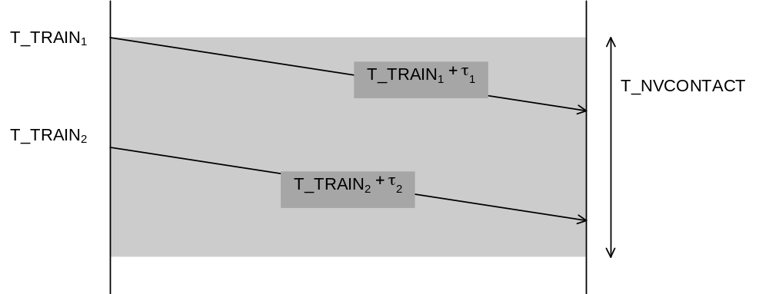
Figure 36: Supervision of the Radio Link (Message received within the Window)
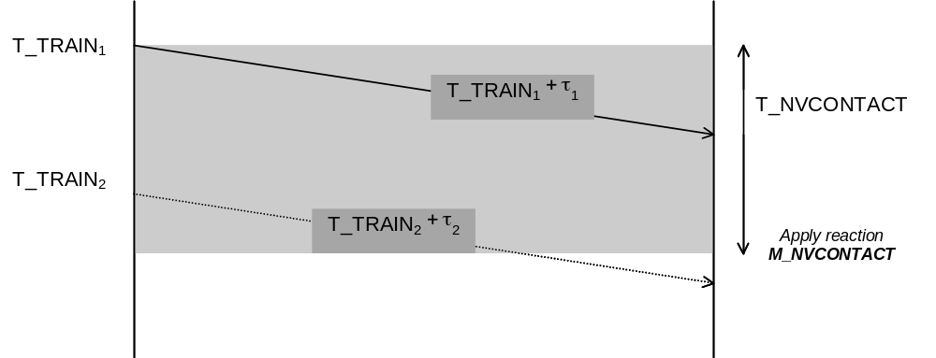
Figure 37: Supervision of the Radio Link (No message received within the Window)

It shall be possible to select one of the following reactions (National value) :
- Train trip
- Apply service brake
- No reaction

For all reactions, the on-board shall release the safe connection and then set-up it again (maintaining the communication session).

When the reaction leads to train trip or a service brake application, the driver shall be informed that no safe radio message has been received in due time.

If the service brake is initiated, the following reaction shall be taken;
- As soon as a new valid message is received, the service brake command shall be released.
- If no new message is received until the train reaches standstill, the current MA, track description and linking information shall be shortened to the current position.

It shall be possible for the RBC to deactivate the supervision of T_NVCONTACT in some areas (e.g. radio hole).

To avoid the expiration of the on-board timer and if no new information is ready to be sent, the RBC shall send an empty message.

Message Acknowledgement
FRS reference: - none

As soon as a valid message including the request for acknowledgement is received, the on-board shall send an acknowledgement to the trackside.

Note: In order to ensure trackside that the on-board has correctly received transmitted information, the RBC may ask the on-board to acknowledge.

The message is valid when all checks have been completed successfully:
- It has passed the checks performed by the Euroradio protocols (see Euroradio specifications)
- It has passed the time stamping checks
- Variables in the message do not have invalid values.

The acknowledgement message shall refer to the identity of the concerned message sent by the RBC.

.In case a train exits from the RBC area and no order to terminate the session is received, the on-board equipment shall cyclically send a position report. After a defined number of times (see Appendix A3.1) the on-board equipment shall terminate the communication session and send an error message to the driver.

System Configuration Management

Aim and objectives

During the ERTMS/ETCS systems life time there will be several versions of the system specification.

The objective of the interoperability configuration is to define principles to be applied in situations where on-board and trackside sub-systems have been certified to different versions.

Note: The handling of different software and data versions are out of the scope of the system configuration management.

Evolution of the versions

The evolution of the versions of the ERTMS/ETCS system shall be sequential, i. e. there shall only be one direct upgrade of an existing version and no branch is accepted.

The version of the ERTMS/ETCS system shall be identified by a version number which complies with the following :
- Each version number will have the following format: X.Y, where X is any number between 1 and 7 and Y is any between 0 and 15. Examples: 1.12, 6.8, 7.0.
- The first number distinguishes not compatible versions.
- The second number indicates compatibility within a version X.
- If the first number of two versions are the same, that indicates that those versions are compatible, independently of the second number. (e.g. version 3.5 is compatible with 3.3, 3.0, 3.14,…).

The on-board equipment version X shall know whether it is compatible with trackside versions lower than X.

Management of ERTMS/ETCS system versions

Every message transmitted by the balises, Euroloops and Radio Infill Units shall contain only the data related to one version. It is not possible for the balises, Euroloops and Radio Infill Units to transmit data correspondent to several versions.

All messages transmitted by one RBC shall contain data only related to one version.

The on-board equipment may operate with several ERTMS/ETCS system versions.

In case the on-board and trackside systems have different version of the ERTMS/ETCS system, the on-board shall decide whether it can use the data received from the trackside.

In case the established version number of a balise group equals to X = 0 with any value for Y the balise group shall be ignored.

In levels 1, 2 and 3 the on-board equipment shall check the ERTMS/ETCS system version transmitted by any balise. If the version is not compatible, the train shall be tripped and an indication shall be given to the driver.

In level 1 the on-board equipment shall check the ERTMS/ETCS system version transmitted by any Euroloop and Radio Infill Unit found. If the version is not compatible, the on-board equipment shall ignore the information coming from the incompatible device and continue with the previously received MA.

The on-board equipment shall check the ERTMS/ETCS system version transmitted the first time any RBC (only level 2/3) is contacted (including RBC hand over). If the version is not compatible, the on-board equipment shall reject any information coming from the contacted RBC and continue with the previously received MA.

When no compatible version has been established between the on-board equipment and RBC (only level 2/3) the on-board equipment shall send a version independent message indicating No compatible version found and then terminate the communication session. An indication shall be given to the driver.

Note: In levels 2 and 3, the RBC can have different version from the balise groups, (e.g. balise groups 2.1 and RBC 3.6).

It shall be possible for the receiver to discriminate between information belonging to different versions.

In compatible versions new information, which is not known by older versions shall be ignored.

In level 0 and level STM, no reaction shall be applied by the on-board equipment after passage of a balise group with no compatible version.

Justification: This is needed to be able to handle commissioning areas

The way to transmit the balise, Euroloop, Radio Infill Unit and RBC version shall not be subject to evolution.

Deleted .

Deleted .

System Data

Fixed Values
FRS reference: - none

Note: Appendix to chapter 3 contains a list of Fixed values used as system parameters in the supervision. These parameters are system related and can easily be changed in later versions of the ERTMS/ETCS if required. These parameters are not defined as National data.

National / Default Values
FRS reference: 3.10 National Values, 3.11 Default Values

Note: Appendix to chapter 3 contains list of National and Default Values.

Trains shall be supervised according to the National Values of the current infrastructure if they are available on-board.

National Values shall be applicable at a defined location.

Evaluating a balise group message, the balise identity information referring to the country or region shall be used to ensure that correct National Values are used.

Default Values shall be used as fall back values if:
- the National Values are not available, or
- if a mismatch has been detected between the country or region identifier read from a balise group and the corresponding identifier(s) for which a set of national values is used onboard.

National Values shall always be transmitted as the complete set (i.e. no sub-set, no individual values)

The set of National Values currently used when the on-board equipment is switched off (i.e. in No Power mode) shall be retained and re-used when powered on.

Justification: The aim of this requirement is to limit the number of balise groups containing National Value information. Once the set of National Values has been received on-board, there is no need to re-load the information unless National Values change, the on-board equipment loses the information (failure situation), or the train enters an area requiring different National Values.

The applicable set of National Values data shall be transmitted from the trackside on transition between areas requiring a different set of National Values.

The on-board equipment shall manage only one set of announced but not yet valid National Values at a certain time, i.e., if a new set of National Values is received, a previously received set which is not yet valid shall be deleted.

If a set of National Values becomes invalid, then it shall be deleted.

Train Data
FRS reference: 4.1.2 - Train and driver Data Entry (4.1.2.17 not supported)

Train Data except train running number shall neither be provided nor modified by ERTMS/ETCS trackside equipment.

The following Train Data must be acquired by the ERTMS/ETCS on-board system of a leading engine
- Train category
- Train length
- Deceleration data (referring to the traction/brake models)
- Maximum permitted speed for the train, taking into account the maximum speed of every vehicle contained in the train.
- Loading gauge
- Axle load
- Power supply accepted by the train
- Train fitted with airtight system
- List of STM available on-board
- Additional data for the available STMs
- Train running number

The ERTMS/ETCS on-board equipment shall acquire the train running number from driver input, from ERTMS/ETCS external sources (i.e. from the train interface) or from the RBC.

It shall be possible to enter train running number also in a non-leading engine. Other Train Data need not be acquired by the ERTMS/ETCS equipment in a non-leading engine.

After confirmation or when entering into a level 2/3 area, the ERTMS/ETCS on-board equipment of the leading engine shall send the following data to the RBC (in level 2/3 only)
- Train category.
- Train length.
- Maximum permitted train speed.
- Loading gauge.
- Axle load.
- Power supply accepted by the train.
- Train fitted with airtight system.
- List of STM available on-board
- Train running number

With the exception of train running number entry of Train Data by the driver shall only be possible if the train is at standstill.

Additional Data

Driver ID

The driver ID shall be used to identify the responsible person for operating an active desk.

Note: This data is used for recording purposes only.

It shall be possible for the driver to change driver ID while the train is running.

It shall be possible to enter driver ID also in a non-leading engine.

ERTMS/ETCS Level

The driver shall have the possibility to enter the ERTMS/ETCS level during a start of a mission.

The ERTMS/ETCS level information shall be required for train operation except sleeping mode.

In normal operation after the start of mission the driver shall not have to select the ERTMS/ETCS level (all other level transitions are executed automatically). To cover degraded situations the driver shall have the possibility to select a level.

Radio Network identification / RBC Identification / Telephone Number

Note: The RBC identity and telephone number is needed to establish a connection to the RBC via radio.

If in level 2/3, at start of mission, the driver shall have the possibility to enter/re-enter the RBC contact information (including RBC identity, RBC telephone number, and the identity of the radio network to be used), for details see chapter 5, Start of Mission procedure.

The driver shall have no further possibility to modify the RBC contact information (all further modifications of this data are executed automatically).

ETCS Identity

Each ERTMS/ETCS equipment shall be assigned a unique ETCS identity within its group, i.e.
- RBC’s shall have unique identities
- On-board equipments shall have unique identities (train identity)
- Balise groups shall have unique identities
- Loops shall have unique identities
- Radio in-fill units shall have unique identities.

Deleted

Adhesion Factor

The adhesion factor shall be used to adjust the braking model of the train.

The adhesion factor may be changed while the train is running.

It shall be possible to update the adhesion factor from trackside and - if permitted by a National value - by the driver.

The adhesion factor shall be sent as profile data from trackside when needed.

The driver shall be informed that the adhesion factor has been changed due to information from the trackside.

The selection of the adhesion value from trackside or by driver entry shall be limited to the options slippery rail/ non slippery rail (for the values refer to A3.1: List of Fixed Value Data).

The onboard dynamic speed monitoring function shall use the most restrictive value of the adhesion factor selected by the driver and the adhesion factor given by trackside.

The default value for the adhesion factor shall be the highest value (i.e. not slippery rail).

A modification of the adhesion factor by the driver shall be immediately taken into account. If given from the trackside, it shall be taken into account in a safe way in the dynamic speed monitoring based on the profile information.

Date and Time

Each ERTMS/ETCS on-board equipment shall be able to provide the date (day, month, year) and time (hour, minute, second) in Universal Time Co-ordinated (UTC) and Local Time.

The local time may be presented to the driver, while the UTC shall be used for the juridical recording.

Deleted.

Data Entry / Modification Process

Note: The process refers to the entry of Train Data and additional data.

The data entry / modification process shall be triggered automatically during start of mission, or when selected by the driver.

If in ERTMS/ETCS level is 2 or 3, the on-board equipment shall send the modified set of information to the RBC.

The RBC shall acknowledge the reception of Train Data.

In case the Train Data regarding train category, axle load, loading gauge or power supply has been changed the track description and MA shall be shortened to the current position of the train see section 3.7.3.3.

Deleted

Recording of Juridical Data

On-board Recorder
FRS reference: 4.3.10 –Recording the ETCS information

Note: Appendix to chapter 3 defines which data to be recorded and when.

Recording function is part of each ERTMS/ETCS on-board system. The juridical recorder function shall be used only to record and allow the downloading of the recorded data that may be used for legal purpose after hazardous situations.

Note: The juridical recorder is not intended for maintenance purposes and hence no additional functions are included for maintenance recording

It shall be possible to determine the date and time (UTC), train position, train speed, driver ID, ETCS equipment ID, the ETCS level and the active mode of the on-board system for each recorded event.

The events to store in the juridical recorder shall allow analysing the cause of an accident.

It shall be possible to download the recorded data via a downloading tool.

The Juridical Recorder shall store the complete set of data (as listed in A3.3.1) for at least the last 24 hours in service.

The Juridical Recorder shall be able to record all the relevant events produced in the worst case situations (i.e. train at full speed).

It shall be possible to record data from external sources, i.e. via the train interface.

The Juridical Recorder shall store a reduced set of data (as listed in A3.3.2) for the last 8 days in service.

Appendix to Chapter 3

A3.1 List of Fixed Value Data

Fixed Value Data | Value | Name
The number of times to try to establish a safe connection. | 3 times
Repetition of radio messages | 3 times
Speed difference between Permitted and Emergency Brake Intervention limit, minimum value | 5 km/h | DV_EBI_{min}
Speed difference between Permitted and Emergency Brake Intervention limit, maximum value | 15 km/h | DV_EBI_{max}
Constant defining the relation between Permitted and Emergency Brake limit | 0.1 | C_EBI
Maximum distance for calculating the geographical distance | 10 000 metres | D_{GEO}
MA request repetition cycle, default value | 60 s | T_{CYCRQSTD}
Mode transitions:  Time to acknowledge a mode transition | 5 s | T_{AMT}
Adhesion value (1), non slippery rail | 100 %
Adhesion value (2), slippery rail | 70 %
Distance of metal immunity in Levels 0/STM | 300 metres | D_Metal
Default location accuracy of a balise group | 12 metres

A3.2 List of National / Default Data

National / Default Data | Default Value | SRS Name  (Reference only)
Modification of adhesion factor by driver | Not allowed | Q_NVDRIVER_ADHES
Shunting mode (permitted) speed limit | 30km/h | V_NVSHUNT
Staff Responsible mode (permitted) speed limit | 40km/h | V_NVSTFF
On Sight mode (permitted) speed limit | 30km/h | V_NVONSIGHT
Unfitted mode (permitted) speed limit | 100km/h | V_NVUNFIT
Release Speed value | 40km/h | V_NVREL
Distance to be used in Roll Away protection, Reverse movement protection and Standstill supervision | 2m | D_NVROLL
Use service brake when braking to a target | Yes | Q_NVSRBKTRG
Permission to release emergency brake | Only at standstill | Q_NVEMRRLS
Max. speed limit for triggering the override end of authority function | 0km/h | V_NVALLOWOVTRP
Permitted speed limit to be supervised when the “override EOA” function is active | 30 km/h | V_NVSUPOVTRP
Distance for train trip suppression when override end of authority function is triggered | 200m | D_NVOVTRP
Max. time for train trip suppression when override end of authority function is triggered | 60 s | T_NVOVTRP
Change of driver ID permitted while running | Yes | M_NVDERUN
System reaction if radio channel monitoring time limit expires (T-Contact) | No reaction | M_NVCONTACT
Maximum time since creation in the RBC of last received telegram. | ∞ | T_NVCONTACT
Distance to be allowed for reversing in Post Trip mode. | 200 m | D_NVPOTRP
Max permitted distance to run in Staff Responsible mode | ∞ | D_NVSTFF

A3.3 List of events to be recorded in the Juridical Recorder

The following events/information shall be recorded in the juridical recorder and in the following circumstances:

A3.3.1 Complete set of data
TRIGGER | EVENT/Information
Detection of failure in the recording function | JRU failure
Selection / Change of Mode | Current mode
Selection / Change of Level | Current level
Data Entry Completed | Data entry/Train Data and Additional Data
Start up | ETCS ID
Emergency Brake Command / Revocation | Emergency brake state
Service Brake Command / Revocation | Service brake state
Every 5 seconds | Current speed
When received | Message from balise groups
When received | Message from Euroloop
When received | Message from Radio Infill Unit
When received | Message from RBC
When sent | Message to RBC
When the driver acts on the on-board system (MMI, Train Interface) | Driver’s actions
When this event occurs and it is still possible to record it. | SYSTEM FAILURE
Balise group error (all types of reception faults) | NID_C and NID_BG
Radio link supervision error (maximum time since the reception of the previous message has expired) | Error identifier
When changed | All the indications to the driver not mentioned in the previous fields (i.e. text messages, permitted speed, target speed)
New data at interface | Data from external sources

A3.3.2 Reduced set of data
TRIGGER | EVENT/Information
Emergency brake command/revocation | Emergency brake status
When the driver acts on the on-board system (MMI, Train Interface) | Driver’s actions

A3.4 Handling of Stored Information in specific Situations

A.3.4.1 Introduction

A.3.4.1.1 All data that can be stored onboard may be influenced in special situations.

A.3.4.1.2 The situations acting on the “status” of stored information are:
- the execution of a conditional emergency stop (3.7.3.3, 3.10.2.1.2);
- the reception of a shortened MA (3.7.3.3);
- the stored MA is shortened due to a section time-out (3.7.3.3, 3.8.4.2.2);
- the SvL is shifted (to the DP if any or to the EOA) due to an overlap time-out (3.8.4.4.2) ;
- the stored MA is shortened due to an end section time-out (3.7.3.3, 3.8.4.1.2);
- a cooperative MA revocation is granted by the onboard (3.8.6.2);
- inconsistency in a balise group marked as unlinked (3.16.2.5.2);
- a linking reaction led to a service brake and the train is at standstill (3.16.2.6.2) ;
- the reaction due to the supervision of the radio link led to a service brake and the train is at standstill (3.16.3.4.5 b) ;
- the train category, axle load, loading gauge and/or power supply is/are changed (3.19.1.5) ;
- driver closes the desk during SoM ;
- RAMS related supervision functions led to a service brake and train is at standstill (3.16.2.7)

A.3.4.1.3 Depending on the situation, the action can be:
- data is deleted,
- data is reset (set to initial states)
- data status is unchanged,
- data is to be revalidated

D = Deleted | U = Unchanged | R = Reset | TBR = To Be Revalidated

Data Stored on-board | Situations listed above
Data Stored on-board | a - f (a new stop location is defined) | g – j, l (a new stop location is defined) | k (driver closes desk during SoM)
National Values | U | U | U
Linking | D[1] | D[1] | D
Movement Authority | D[1] | D[1] | D[5]
Gradient Profile | D[1] | D[1] | D
International SSP | D[1] | D[1] | D
Axle load speed profile | D[1] | D[1] | D
STM speed restrictions | D[1] | D[1] | D
Level Transition Order | U | U | D
List of balises for SH area | D | D | D[5]
MA Request Parameters | U | U | U
Position Report parameters | U | U | U
List of Balises in SR Authority + SR speed and distance | U[2] | U | D[5]
Temporary Speed Restrictions | U | U | D
Signalling related Speed Restriction | D[1] | D[1] | D[5]
Route Suitability Data | D[1] | D[1] | D
Plain Text Information | D[1] | D[1] | D
Fixed Text Information | D[1] | D[1] | D
Geographical Position | U | U | U
Mode Profile | D[1] [7] | D[1] [7] | D[5]
RBC Transition Order | D[1] | D[1] | D
Radio Infill Area information | D[1] | D[1] | D
EOLM information | D[1] | D[1] | D
Track Conditions excluding big metal masses | R[1] | R[1] | R
Track condition big metal masses | R[1] | R[1] | R
Emergency Stops | U | U | D
Location | U | U | U
Train Data | U | U | TBR
Adhesion factor | U | U | D
ERTMS/ETCS level | U | U | U
Driver ID | U | U | TBR
Radio Network ID | U | U | U
RBC ID/Phone Number | U | U | U
Train Running Number | U | U | TBR
Last eight reported balise group identities | U | U | U
Reversing Area Information | D[1] | D[1] | D
Reversing Supervision Information | U | U | D
Memorised balise groups for special position report | U | U | U
Track Ahead Free Request | U[6] | U | D
[1]: beyond the new stop location
[2]: The considered situations cannot occur when a list of balises to be used in SR is available onboard. Indeed, the onboard is in SR mode and since no MA or track description are stored onboard, no new stop location may be defined.
[3]: The location must be recalculated according to the new train orientation.
[5]: The considered situation cannot occur because acceptance of this information has led to exit from SoM procedure.
[6]: The considered situations b-f cannot occur when a TAF request is stored on-board

[7]: If the start location of the Mode Profile is beyond the new stop location, the ackowledgement window of the Mode Profile shall be deleted as well

A.3.4.1.4 NOTES:

A.3.4.1.4.1 “Location” contains LRBG, distance travelled from LRBG, position of the front end in relation to the LRBG, the confidence interval and the orientation in relation to the LRBG.

A.3.4.1.4.2 The following information is not considered to be stored information:
- Repositioning information
- Session Management
- Danger for SH information
- Assignment of Co-ordinate system
- Infill Location Reference
- Location Identity (NID_C + NID_BG transmitted in the balise telegram)
- Recognition of exit from TRIP mode
- Acknowledgement of Train Data
- SH refused
- SH authorised
- Configuration Determination
- Intentionally deleted
- Intentionally deleted
- Revocation of Conditional Emergency Stop
- Temporary Speed Restriction Revocation
- Establishment of session
- Acknowledgement of session termination
- Default Balise Information
- Track Ahead Free up to level 2/3 transition location

